

**APPITS**

16

**FXWEBKIT**

**Manage, Analyze & Trade**

**Mohammad Galya**

# About FXWEBKIT

-FXWEBKIT is a complete solution for manage FOREX users and their trades , analysis and manage connecting to MT server .

-There are three types of users who can use this software admin's, clients with their MT users and public persons, each one of them has his own area to manage his system through it, those three areas are **admin area**, **Clients area with agent area** and **pubic website.**  
 **FXWEBKIT users types:-**

1. **Admin's :**

-the admin is who control the entire FXWEBKIT software ,the admin can control ,and add all users like *clients , agents and MT users* .

-Admin can login to the admin area and configure software settings.

-The public website can be edited and change through admin CMS tools.

-All MT server requests and configuration controlled from admin area.

1. **Clients (FXWEBKIT) :**

Clients are the software users whose enter the clients area where they can control, edit and add their MT users , they also can be agents and get commission through their users whose register through them.  
there are two types of Clients :

1. **Ordinary User**: the user who register through the software directly or the admin add them.
2. **Agent User**: the agent is a client but he agree on agents agreements and the admin assign plans to him so he can invite users to register and trade then he will get commission depend on the plan .
3. **MT users**: the users on MT server who trade and get orders and can get to trade window and trade platforms.
4. **Public person**: anyone who get in public website which is created by the admin CMS.

**FXWEBKIT Areas:-**

In FXWEBKIT there are three major areas each one for some type of users those areas :-

1. **Admin area** :-

this area specialize for system admin's user to control the whole system .

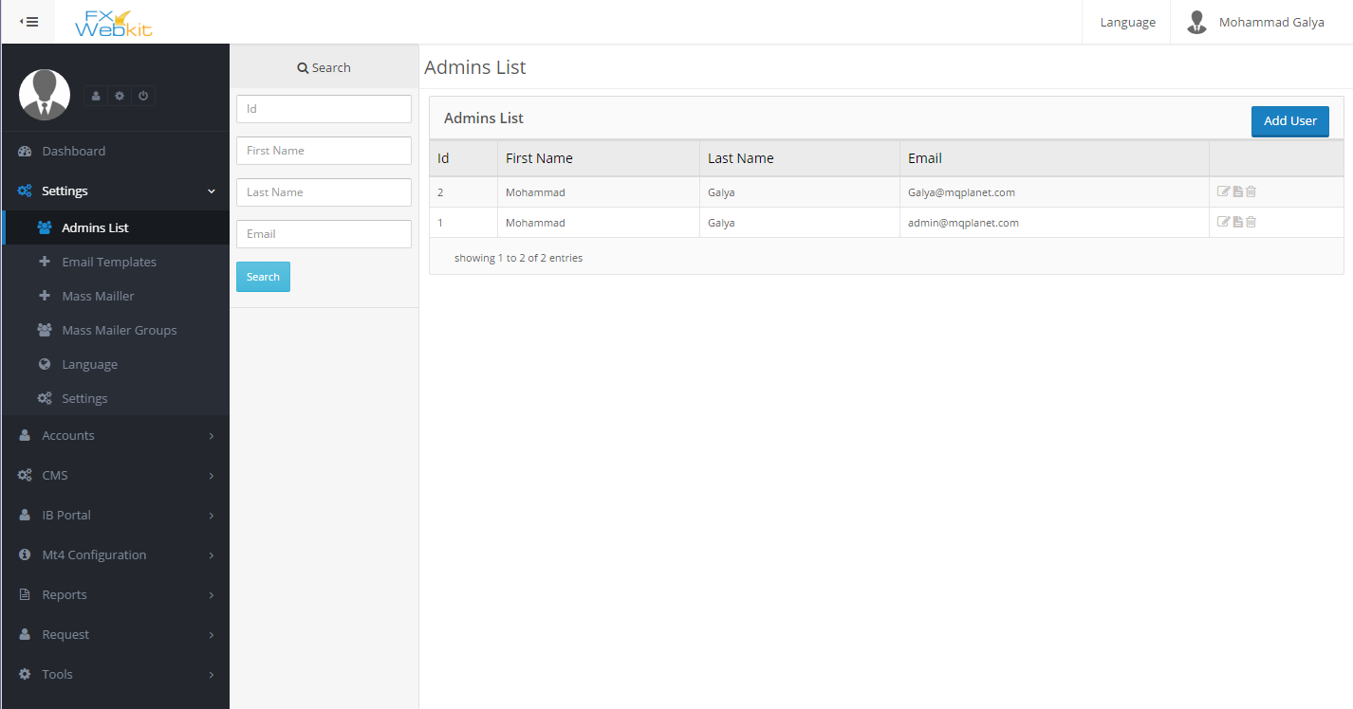

(figure 0.0 )

1. **Client area**:-

- this area specialize for clients users to control their trades and MT users and their agent area .

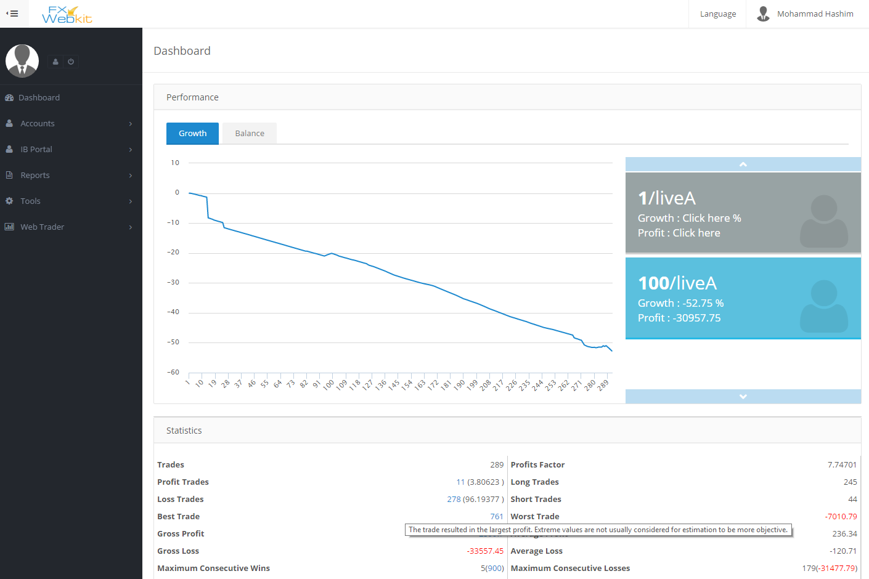

(figure 0.1)

1. **Public area:-**

- it’s the public website available for any one and it’s controlled through admin CMS tools.

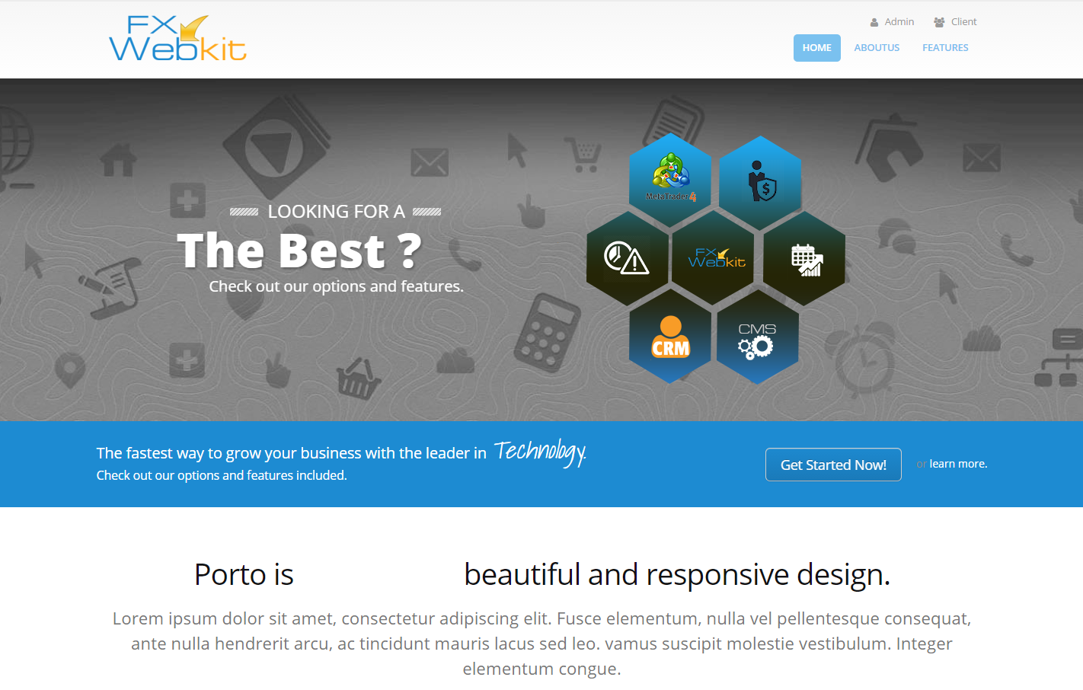(figure 0.2 )

## Admin area:-

This area is to manage the software, accounts of all users with their trading’s reports and filter their requests to MT4 server, you can also manage Agents and their users with commissions and money .

To manage the pubic web site content you can use CMS (Content Management System) module to edit and add content to the public web site .

### Admin Dashboard

Here you can display statistics for clients, MT4 users and too many trading statistics and analysis .

### Settings:-

Settings module contains the main settings for the system in general but each module contains its own configurations.

Admins profiles with full control to their details can be access from this module , emails configurations and mass mail with specialize groups of users to send emails for them , you can also change any word on the system with its translate and manage translation .

#### Features:

1. Easy access to many of the software settings.
2. Full control for emails template and notifications
3. Translate whole of the words in the software.
4. Configuration of the MT servers in one place.
5. Social media Apps to let clients login throw their social media.

#### Settings Menu Sections:-

As we see in (figure 1.0) this module contains varies of section :-

##### **Admin List:-**

The admin who can get in the admin area and control it .

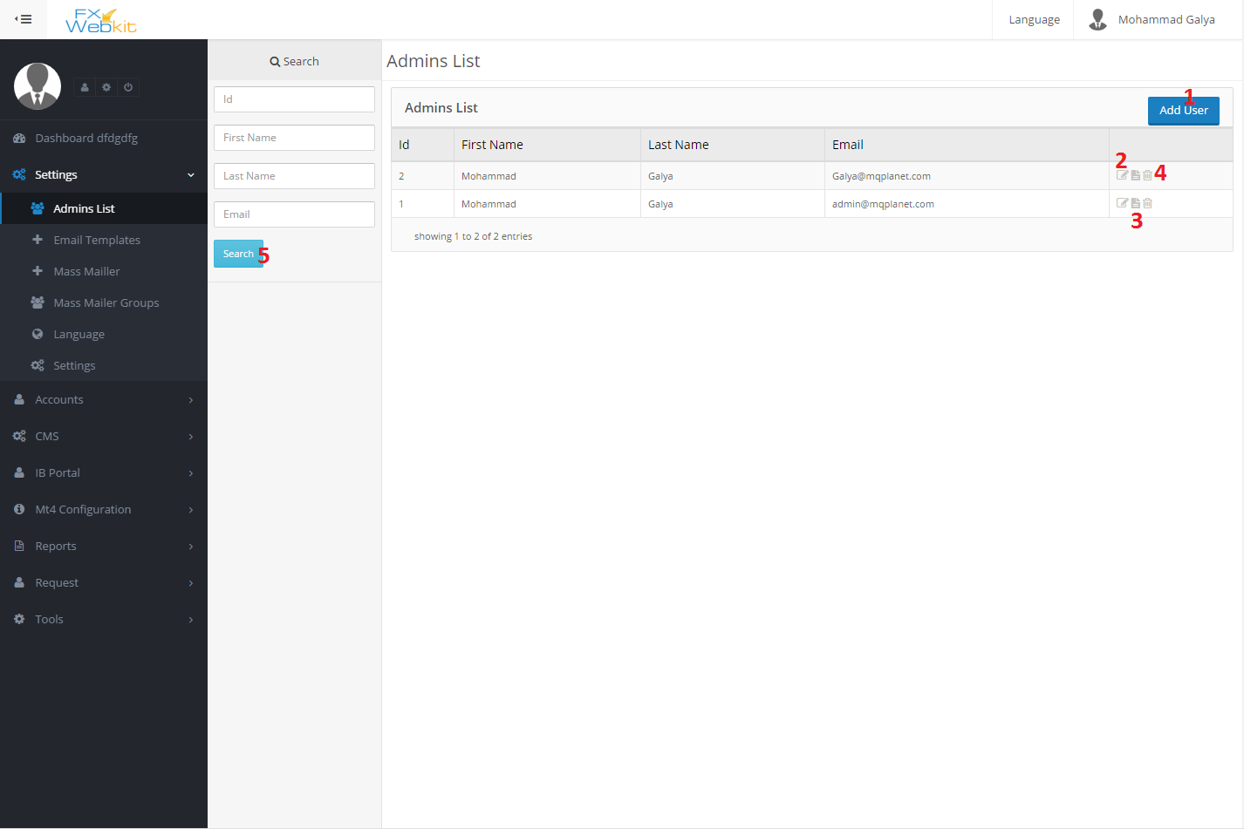

(figure 1.0)

As we see in (figure 1.0) the list of all admin's listed here, this window contains the following :-

1. **Add User(admin) :** add new admin to the system to control admin list .
2. **Edit User details** : to change password and all personal details .
3. **User details** : to see user details click this icon .
4. **Delete User:** If you want to delete the admin ,the admin will be no longer exist and cannot get into the system again.
5. **Search panel :**use this panel to find a specific admin using his ID or part of his first name , last name and email the result will be listed to the right.

##### **Email Templates:-**

In this system there is too many of notifications types and emails send to the users when someone do some action on the system and the email should have specific template .

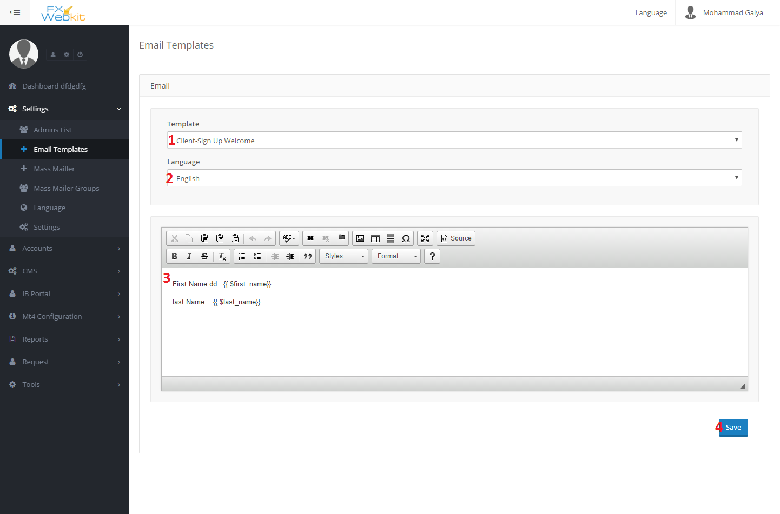

(figure 1.1)

This form just to edit the email templates if the body of email does not appear you have to add the file of the template on templates folder or change language and template name to get the template and edit it:

1. **Template name :** in this case we have email template if new client sign in this email will sent to his email to welcome him .
2. **Language :** you have to have template for each language in your system if you do not have template in the files for specific language the body will not be appear , so have to add the file then try to get this template.
3. **Template body :** the email body which will be sent as we see there is variables look like this :-

**{{ $name }}** this will be replaced with the name of the user before sent it , you have not to change theme just use theme where ever you want to put name of user .

Each template has his own variables do not change anything between brackets just move the whole brackets and put them in the right place .

##### **Mass Mailer:-**

From time to time Admin need to send emails to the users or group of users here come mass mailer part ,the admin write his email or get the saved emails and send the email to users emails in the database or mt4 users emails or to group of users he can select the group from **mass mailer groups**.

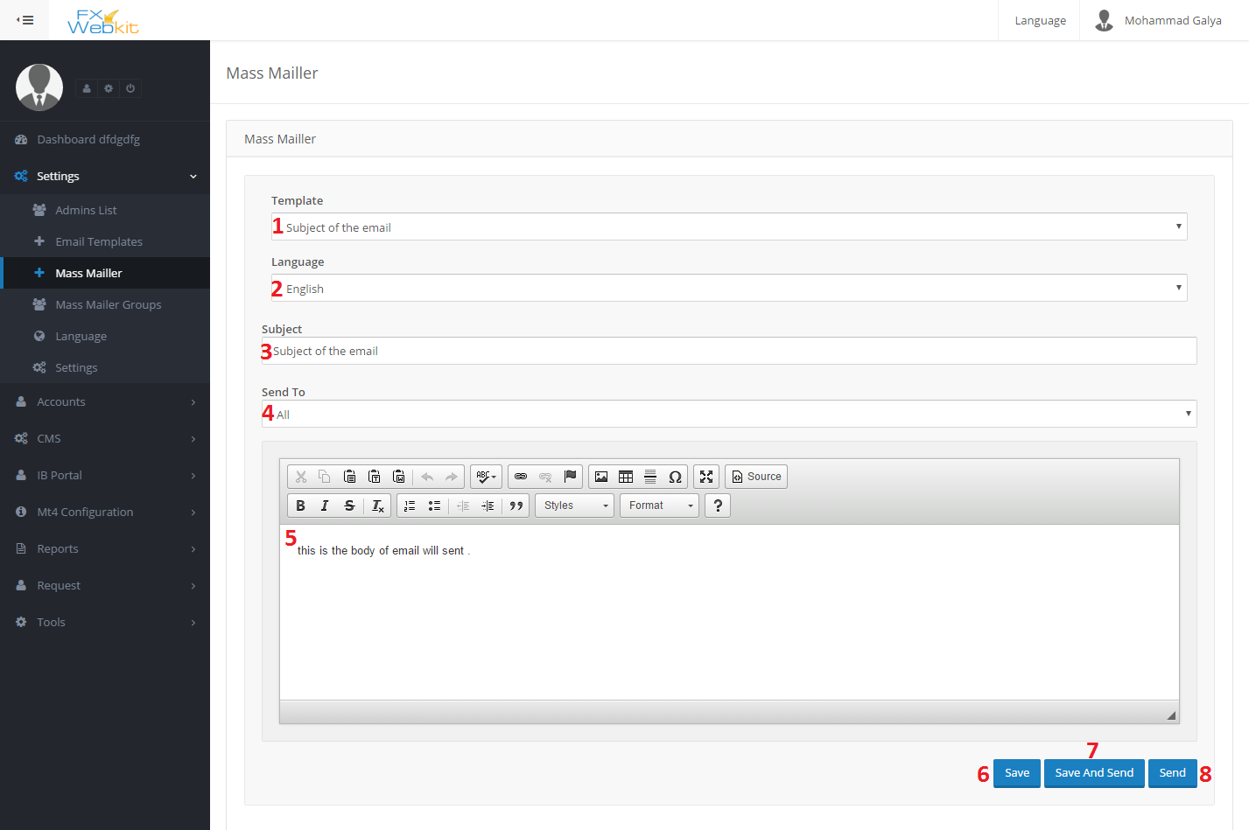

(figure 1.2)

This form to write and send email or get saved email from database and send it.

1. **Template name :** the template come from the saved emails subject’s , that’s mean if you save the email it will be added to emails templates later you can use it to send it again .
2. **Template language :** you can select the language of the template and save it ,it’s just to save it to the database.
3. **Email Subject :** this is the sent email subject and the name of the template if you save it to use it later.
4. **Send To** : here you can select the users how you want to send the email to . you can select the admins or clients or group of users this group come **from Mass Mailer Groups** .
5. **Email body**: the Text which will be sent .

##### **Mass Mailer Groups :-**

As we see in mass mailer that you can send email to group of users here you can select this group of user from software users or MT users and put them in one group to make it easy to send mass mail for them.

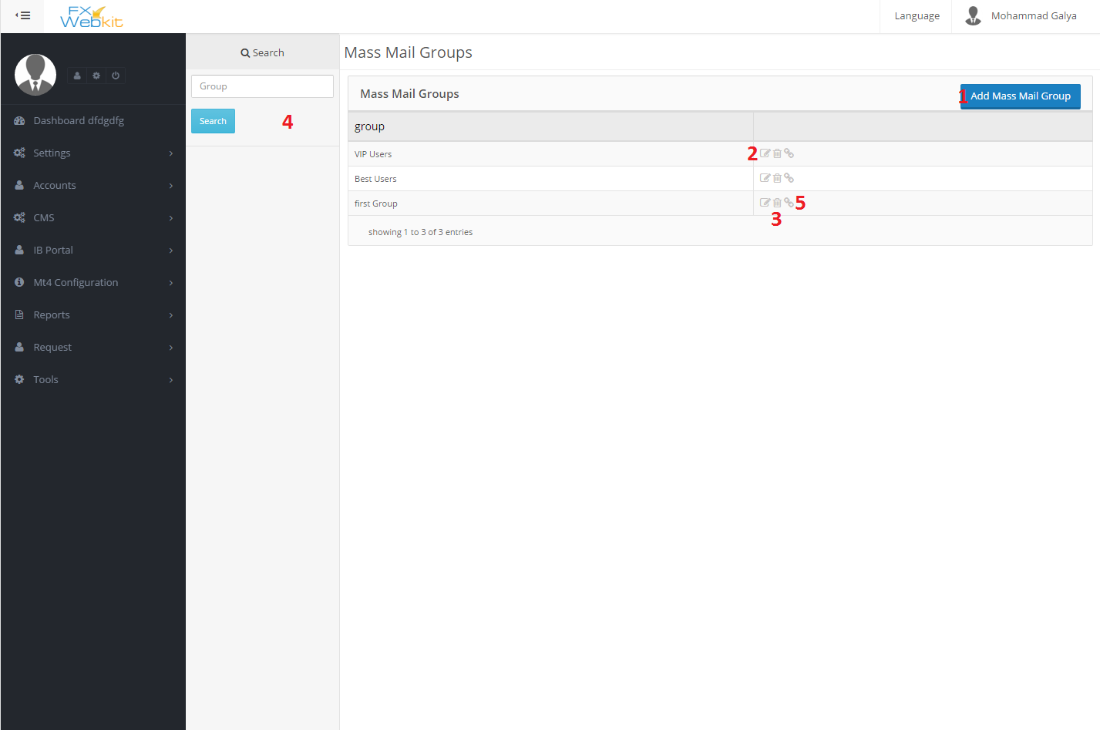

(figure 1.3)

- if the list is empty just click on search button to display all groups.

1. **Add new Mail group Users**: you can group users or MT4 users in one group to by create group for theme .
2. **Edit group name**: just to change group name .
3. **Delete group** : remove group from the software.
4. **Search panel:** by typing part of group name you can find your group .
5. **Add users to group** : by clicking this icon you can add users , Mt4 users to group and remove them from this group as we will see in (figure 1.4) .

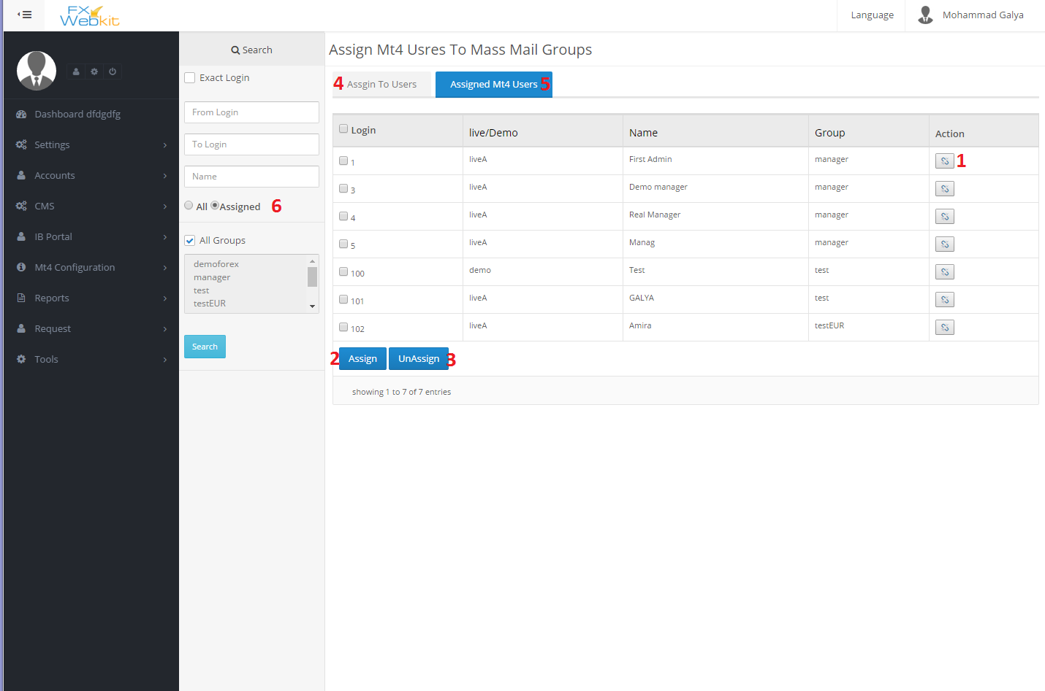

(figure 1.4)

1. **Assign user to group or Un-assign** : Toggle this button to add the user to group or remove the user from the group .
2. **Assign checked users** : after checking the user that you want to assign him to a group , click this button to assign all checked users once .
3. **Un-assign users** : after checking the user who you want to remove from the group, just click this button to remove all checked users once .
4. **List of software users**: as we see we can add mt4 users or users (clients and admins) of software by changing the tabs (assign to users – assigned Mt4 users)
5. **List of Mt4 users** : to assign & un-assign MT4 users .
6. **Filter users** : you can display all users or just the group users by changing the radio button and click search button .

##### **Language:-**

To change any word or text and translate it to any language and the words was separated to modules and files for each module :

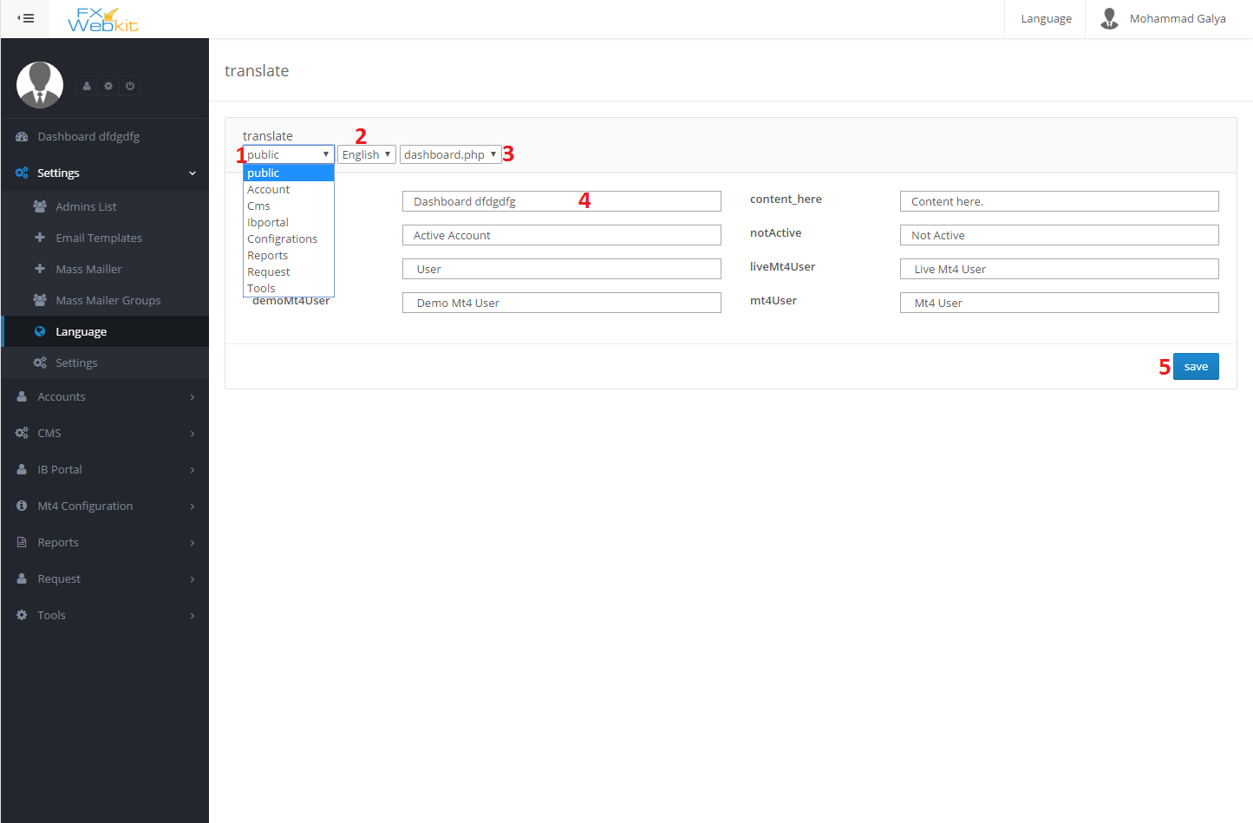

(figure 1.5)

- You can edit every single word in the software

1. **Module name** : the words were separated to modules according to software modules and public words choose the module to see the words and texts to edit them .
2. **Language select**: to translate the words which you see in the English language just type the translated word and click save .
3. **Module files** : every module contain different files for words and texts.
4. **Text input** : edit the text or translate it accordingly to the selected language then click save.
5. **Save button** : to save your changes.

**public settings :-**

Public settings for the software and server settings you can edit them here :

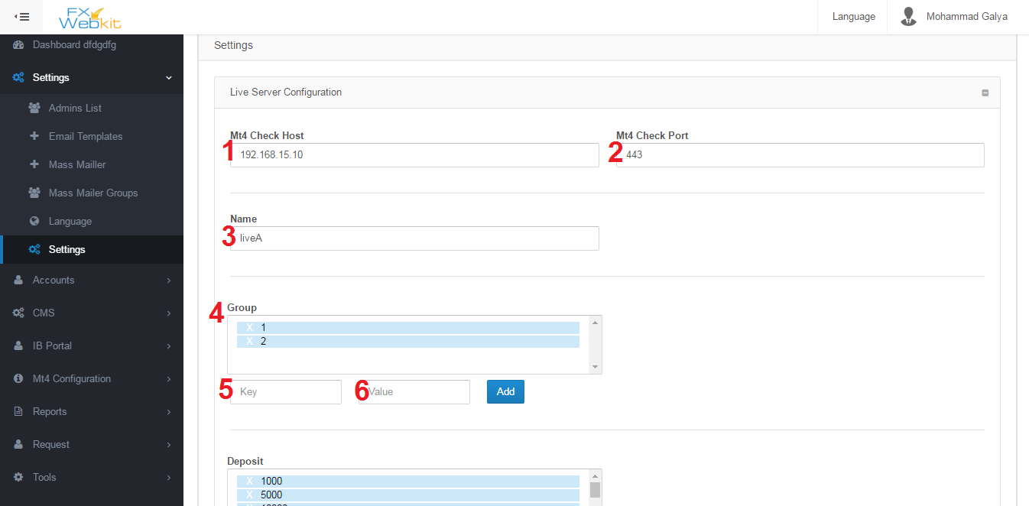

(figure 1.6)

1. **MT Check Host** : meta trader server IP .
2. **MT4 Check Port** : meta trader server port to connect with server through it.
3. **Name**: Name of server where every Mt4 users will be distinct according to the server if it's Live server ,demo or you can name the server.
4. **Group**: Mt4 Users in the server belong to groups so if admin or client wants to add new Mt4 user he has to select the group.
5. **Key** : when software display the list of groups it will display the value and the key for the server so you are free to change the value but the key should be coming from the server ,therefore, you cannot change it.
6. **Value** : descript the group or alias for the group and you can change it as you want.

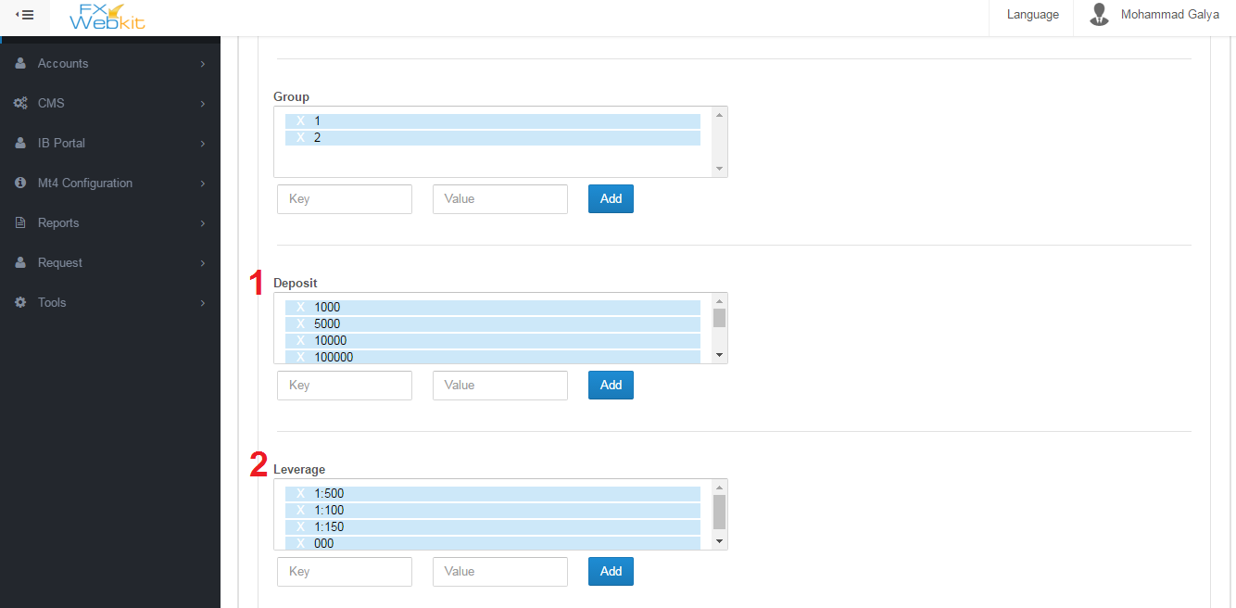

(figure 1.7)

1. **Deposit** : List the deposit numbers which are available on the server and you can delete any one and add also but be careful with the key you have to ask server software developer to know what keys available and you are free with value.
2. **Leverage** : list of leverage on the live server .

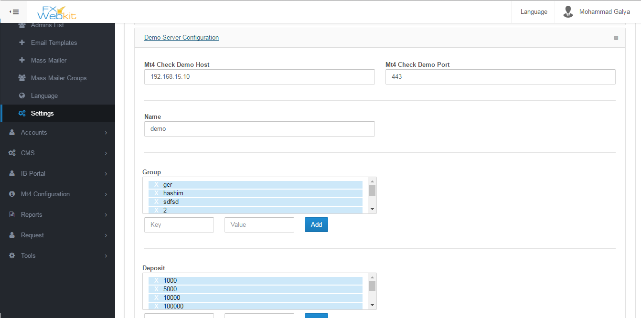

(figure1.8)

As we can see in (figure 1.8 ) live server here we have the same settings for demo server and you can set different settings.

- **Each Admin has his own info you can see it from users list (admin's list ) but this info will be the same for all admin's in general you can descript them as email sender settings:-**

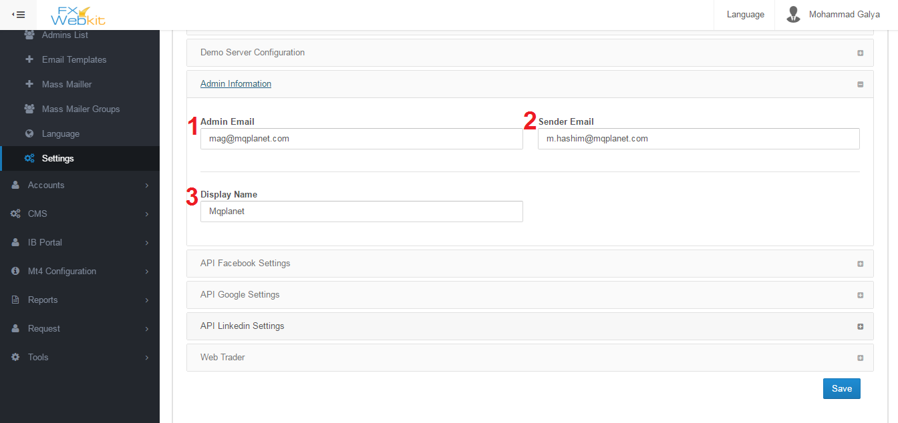

(figure1.9)

1. **Admin Email** : for each notification from the software it will sent to this email and all mass mails will be sent to this email.
2. **Sender Email** : this the email which will all emails out from .
3. **Display Name** : name of the sender in the emails.

**- Fxwebkit client area can be entered by registration or login throw social media and to do this operation you have to make applications on the social networks like facebook ,google+ and linkedin:**

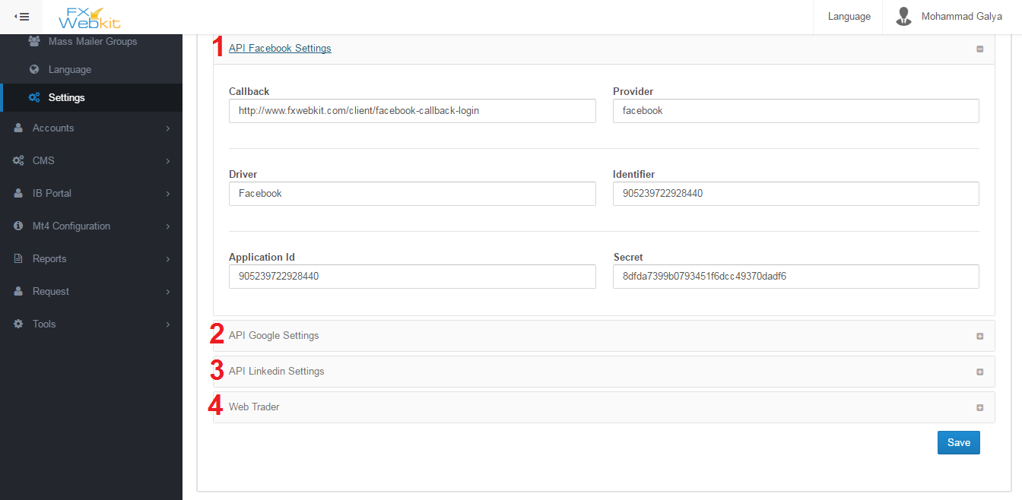

(figure 1.11)

1. **API Facebook** : you can create your own API . please see <https://developers.facebook.com/> to more information about facebook login API.
2. **API Google** : you can create your own API . please see https://developers.google.com/to more information about Google login API.
3. **API Linkedin** : you can create your own API . please see https://developer.linkedin.com/to more information about LinkedIn login API.
4. **Web trade** : the link for online web trade can be inserted here, this link can be displayed or hidden from clients. when you make it available to clients by checking the check box in this tab there will be a new window in clients area to trade online.

**Accounts**

**Accounts List:-**

The accounts list is the list for clients who can enter client area of this software .we have seen Accounts list of admin's the same way for clients, Accounts but with more actions on them:-( see figure 2.0)

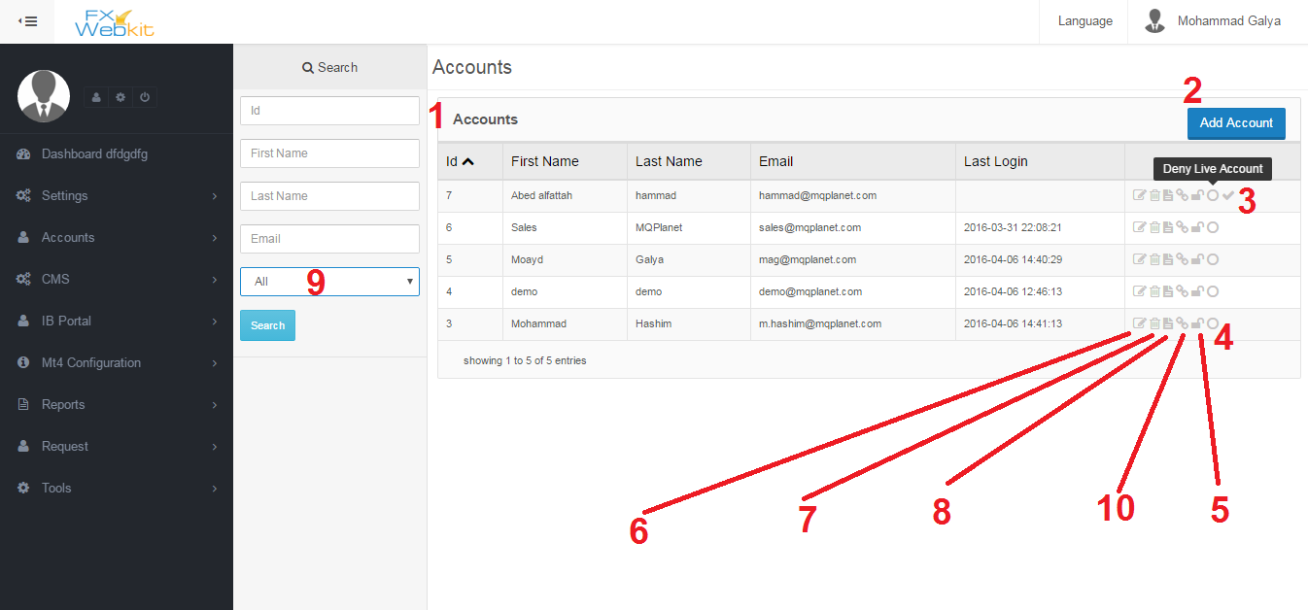

(figure 2.0)

**when you enter this window you have to click search button to see the list i.e. the list will be empty unless you click the search button and it contains the following**:-

1. **Clients accounts list** : all users who can enter clients area will be listed here .
2. **Add Accounts** : this button is to add new client, you can press the button then fill the details then click save and the new user will be listed here.
3. **Active accounts** : when new client registers in the client area for the first time his account will be not active until (according to software configurations) he go to his email and click the activations button (note :you can edit sent email template using settings ->email templates) ,but when you click this activations icon the client account will be active without going to his email ,then he can enter his account.
4. **Deny Create live account**: the clients can add Mt4 Users to Live server as we can see this button can deny some clients from creating live MT accounts on Live server or allowing them .
5. **Block Client** : toggle this button to block or unblock client, when a client is blocked he will not be able to log-in the client area.
6. **Edit Client information**: like admin's list this icon is to edit client info email, password …etc.
7. **Delete Client**: when clicking this icon the client will not be longer exist .
8. **Client Details**: client info and personal details .
9. **Filter users**: If you want to filter the users to see the active and inactive accounts .
10. **Assign MT users to client** : every client have number of MT users on live server and demo server , to determine each client MT users use this button to get into assign MT users to client window . (see figure 2.1 )

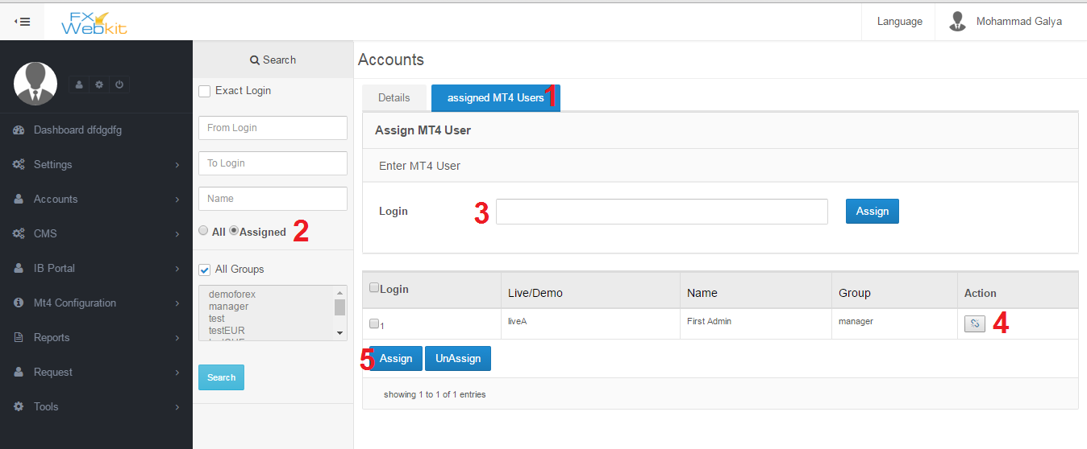

(figure 2.1 )

**To specify each client MT users so when the client enters the clients area he can manage his own MT users and see their details as following**:-

1. **MT Users list** : if you click this tab you can see MT users to the client which we click on in users list, to see this user details use Details tab .
2. **Display All MT users or just the assigned MT users** : filtering the users , if you want to see all MT users check **All** then click search button then you can seeall and new MT users to this user . if you want to see the assigned MT users Check **assigned** then search to see this user (client ) MT users.
3. **Fast assign Login(MT user)** : just type MT users login and click assign to add this MT user to this client.

Note : the login will be assigned as alive MT user, to assign a demo MT user check **All** in filter panel and search find your login and click assign button at the end of the row.

1. **Toggle Assign & un-Assign button**: click this button to assign MT user to this user and click it again to un-assign the MT user.
2. **Multi assign and un-assign button**: display all MT users by checking **all** in filter panel then check the MT users, after doing that you can **assign** or **un-assign** them once.

**MT Accounts**:-

In the system we have two servers live and demo with MT users on them, this window is to manage those MT accounts :-

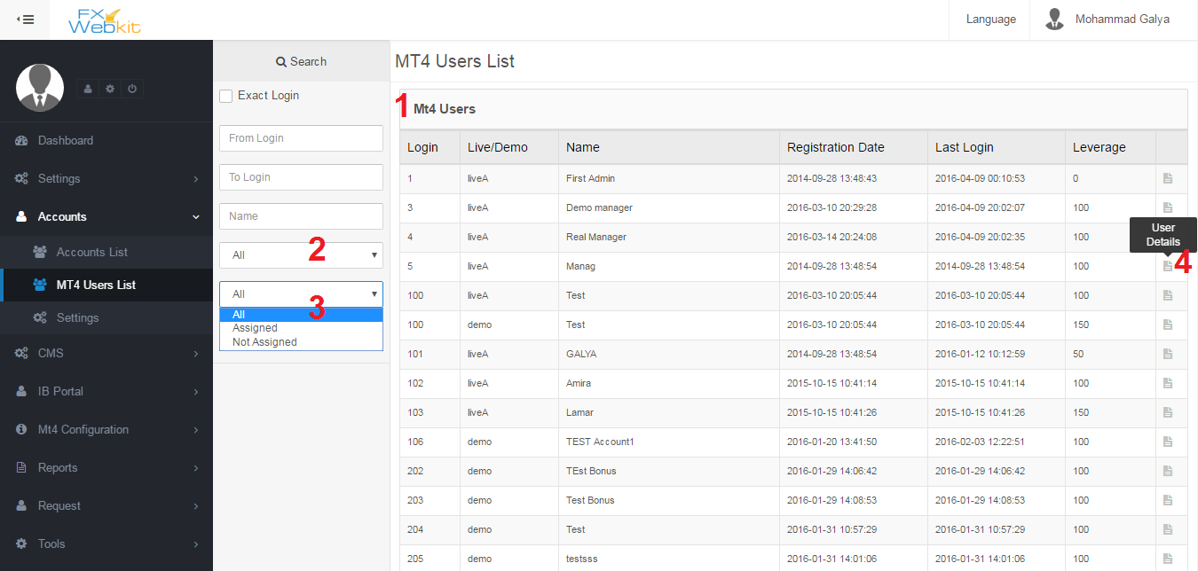

(figure 2.2)

**All MT users live and demo are listed here** :

1. **MT users list**: list of users in live and demo servers.
2. **Filter users live or demo** : you can filter users and distinct the live users from the demo users just by selecting which users you want listed and click search button.
3. **Filter Users (assigned and Not assigned)**: as we see for each system client in past Accounts list has MT users assigned to him this filter will display list of assigned MT users which assigned to one of fxwebkit clients or unassigned MT users.
4. **MT user details**: To manage a certain MT user click on **user details** icon to see the user *summary change leverage, password, internal transfer and withdrawal*, also you can see for any Client (Fxwebkit user) this MT user assign to. (See figure 2.3)

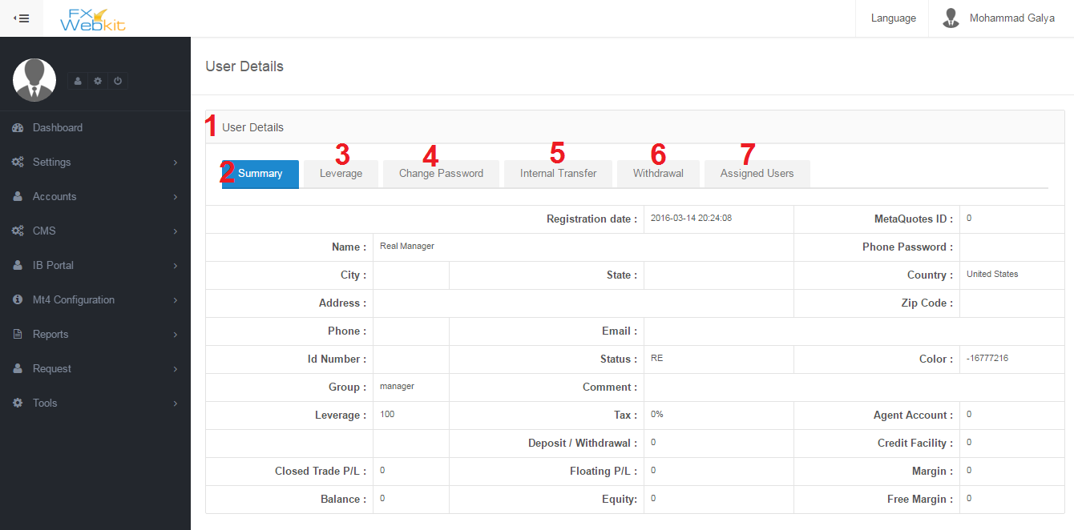

(figure 2.3 )

**MT user details for live or demo users and change this details** :

1. **MT users details** : all MT user details with tabs to change some settings of this MT user through sending request to the server to change those settings.
2. **Summary** : display information of MT user.
3. **Leverage** : this tab to change MT users leverage, you will find list of available leverages on server which we talked about earlier in the public settings tab .
4. **Change password**: MT user can change the password which he use to login to the trading platforms .
5. **Internal transfer** : transfer money from this MT user to another user,just by inserting MT login and the amount then click**send** button .

Note : the admin can control the send to accounts so he can allow if this user can send to any MT user or just to his MT users , we will see this option in the next settings window.

1. **Withdrawal:** just type the amount and click **send** .
2. **Assigned Users**: Client users(Fxwebkit users) has their MT users so to see which user this MT user belong to click this tab to list users that this MT user belong to and to remove this relation **un-assign** any one of them.

**Settings :-**

**This setting just for accounts module to configuration Accounts module and MT users operations** :

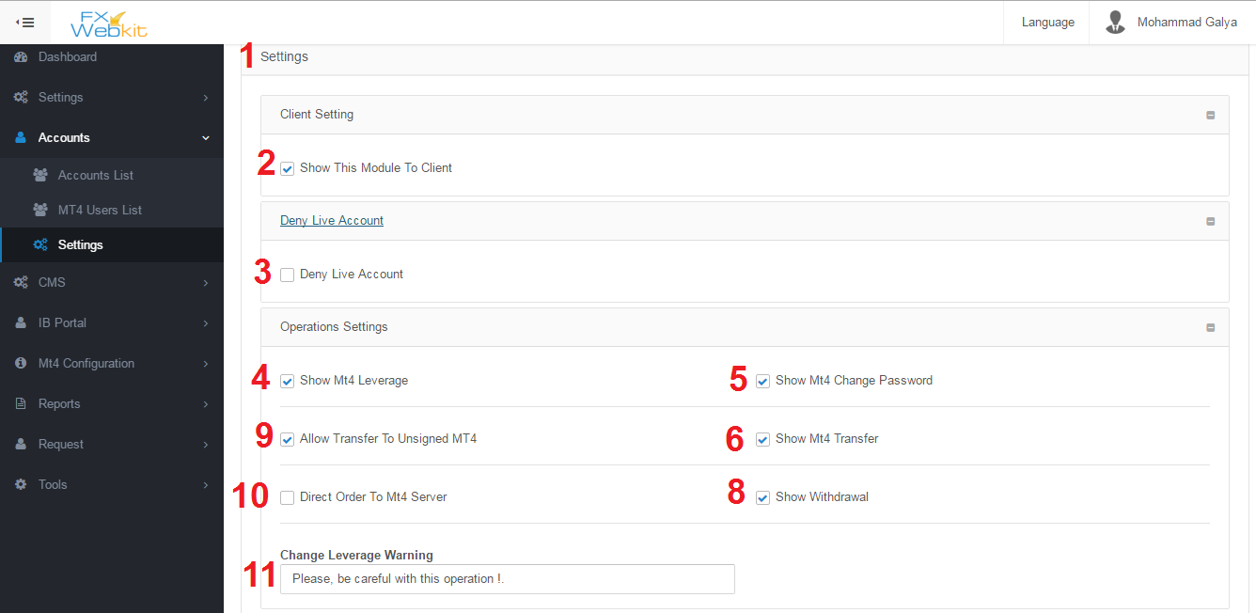

(figure 2.4)

**Settings to control accounts and Mt4 operations:-**

1. **Settings Tab**: contain multi tabs to categorize setting according to their uses.
2. **Show this module to client**: in the client area there is accounts menu and to hide it from client area just remove check from this checkbox.
3. **Deny Live Account** : when new client register in the Fxwebkit software if this option checked the client cannot create live MT user until the admin allow him by checking the icon on accounts list on users list(see number 5 in accounts list ).

But if this option not checked and new user(client) register in Fxwebkit then the admin checked this option the user can create live MT account until admin deny him from creating MT live account.

1. **Show Mt4 Leverage**: in MT user details window there is Change leverage tab this tab can be hidden to client if this option not checked.
2. **Show Mt4 Change Password**: in MT user details window there is Change Passwordtab this tab can be hidden to client if this option not checked.
3. **Show Mt4 Internal Transfer**: in MT user details window there is Internal **Transfertab** this tab can be hidden to client if this option not checked.
4. **Show Mt4 Withdrawal**: in MT user details window there is **Withdrawaltab** this **tab can be hidden to client if this option not checked.**
5. **Allow Transfer To unassigned MT users** : The client (Fxwebkit user) has his own MT users if he want to transfer money between them he can use internal transfer in MT users details. But if he want to transfer money to other MT users(who are not assigned to him ) he cannot if this option not checked.
6. **Direct Order To MT server** : we have some orders like change *password, change leverage , add new MT user , withdrawal and internal transfer*, those order sent to MT server and apply them there, if you want to filter these orders and send them first to admin (requests Module) then the admin choose to forward order to the MT server or control them before sending them to the server just remove checkbox check to filter orders and deny direct order to MT server.
7. **Change leverage warning**: this message will be display to client in change leverage tab.

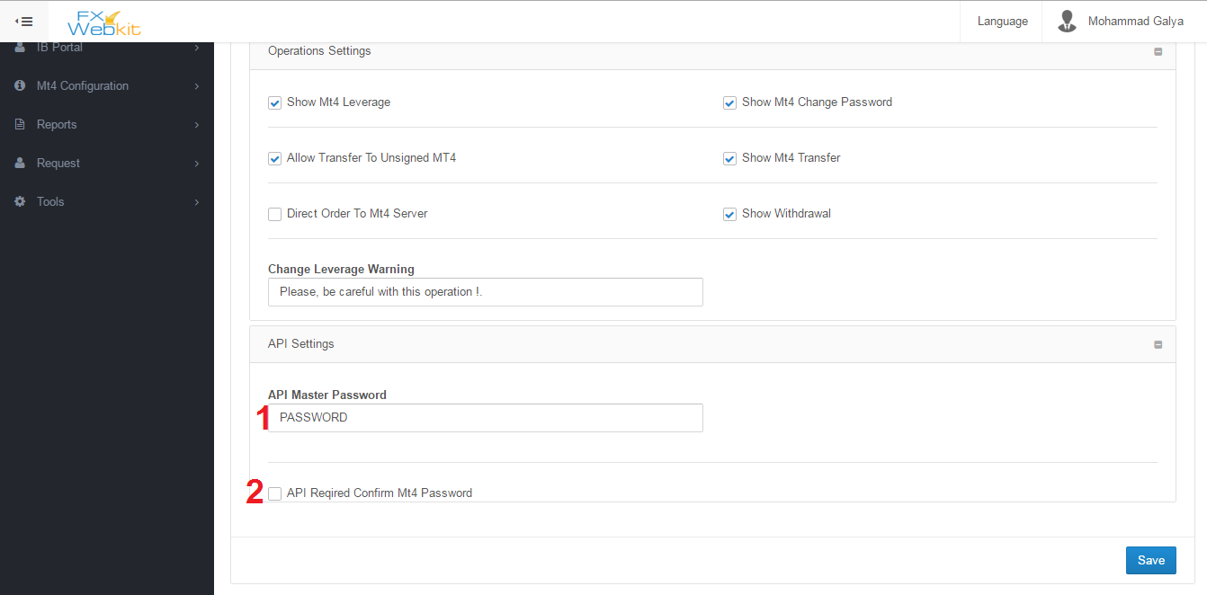

(figure 2.5)

This settings for API developer :

1. **API Master Password** : this password will be sent with request for MT server.
2. **API Required Confirm MT password**: If the API developer need MT user password to confirm order ,the client need to insert the MT password with each order like change leverage

**CMS (Content Management System)**

Fxwebkitsoftware comes with a very astonishing features which is built in CMS to manage website public area content, *add articles, reorder website, add pages, translate* even custom code like *HTML ,JavaScript or even change the whole theme .*

Features :

1. User interface to edit public website without need for developer.
2. Easy to use and fast adding new content.
3. New page by clicking few buttons.
4. Translate and add new language.

Content:

1. Pages:

To add new page to the public website

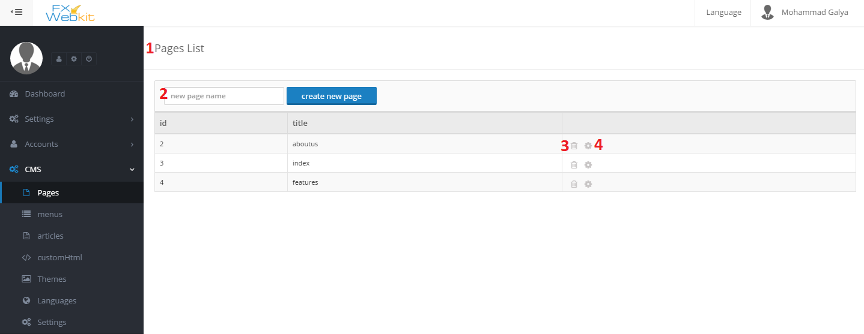

(figure 2.6)

1. **Pages List** : each page in the public web site will be listed here .
2. **New Page Name**: to create new page in the public website type the name of the page and click create new page button to edit content for the new page , we will use page name to create menu link (menu item) for this page.
3. **Delete Page** : to remove the page from the public web site, the contents of the page are independent from the page because the page will tell the content how to look or its positions in the page so the content will be not deleted .
4. **Edit page icon**: to add content for page, reorder content. when you click this icon the following window will be displayed (figure 2.7):-

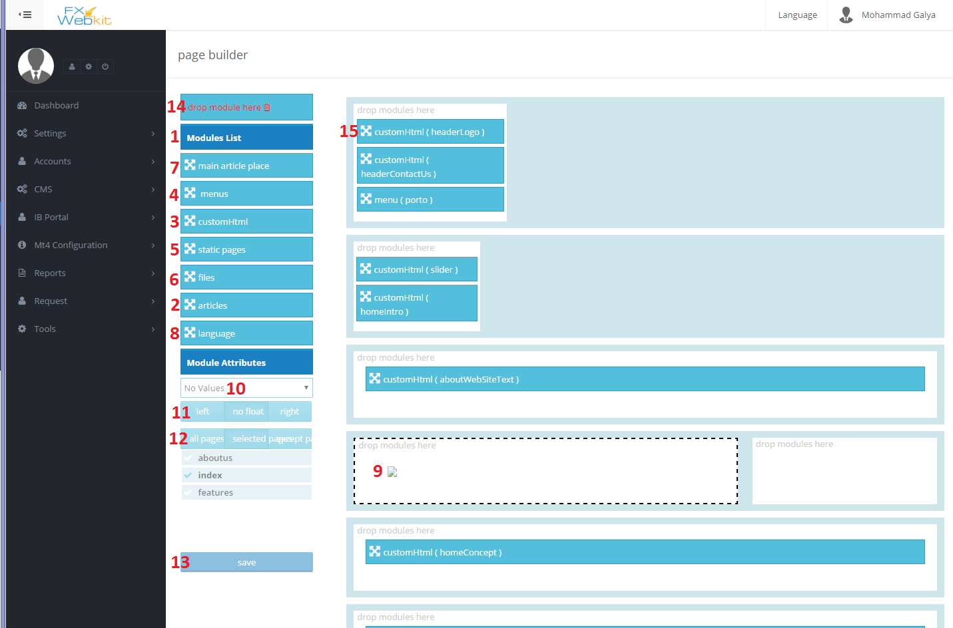

(figure 2.7)

This page to reorder content and insert new content :

1. **Modules List** : all what you can add to public website pages will be listed here . you can add different types of content like **articles , html file, custom HTML , menus and languages dropdown**.
2. **Articles** : in the CMS we have tab for write articles and save them ( figure2.7 ) . To add these articles to website drag this article button and drop it in the white place at the right (number 9) after drop it select article name from the dropdown (number 10) and configure the article align (number 11) , select the pages that you want to display this article on or all pages(number 12) then click save button (number 13).
3. **Custom HTML** : to add new custom HTML , first create custom HTML from custom HTML menu then do the same scenario as in articles (**drag drop in the right place configuration finally click save** ) .
4. **Menus** : see menus in CMS module to create menu with its menu items then **( drag and drop it in the right place of page configure it and then click save) .**
5. **Static pages** : the CMS module allow you to create your own modules different from built-in modules just do the same for add article.
6. **Files** : if you have HTML files and to group them in on module to insert them in the website just create module to them and drag drop the module in the right place select the wanted file then configure it to insert content of the file in this place.
7. **Main article Place**: we see articles module this module a little bit different drag drop this module in the right place this module has no dropdown content(number 10) but when you create new article in article menu you can select the page that you want to display on without going to the page and insert the article in after choosing the page to display the article , all what you have to do is to create menu item for the article , hence ,not for the page then when you call this article (click on menu item ) the page will get the article and insert it in the Main Article Place and will display the page.
8. **Language** : this module insert dropdown select with all languages in CMS menu languages, when the users change the language all articles and other modules will be inserted accordingly to the selected language.
9. **Place to insert modules in** : this place present a position in the public website theme when you drag and drop module in this place it will be inserted in the theme so when users visit public website , you can also reorder modules with drag and drop and change position of module according to the theme section .
10. **Module Content**: some modules require to select type or value of the inserted module like articles when you want to add article on the page we drag drop the article button then we select the article that we want to insert.
11. **Align module in the position**: this option is to align the module to the right or lift in the theme position.
12. **Module pages**: select the pages that you want to display the module on, you can select all to display it in all pages.
13. **Save button** : to save the module place with its configuration.
14. **Delete module** : drag the module from its position and drop it on the delete icon to remove the module from the page (it’s will not delete the module like the article itself just remove it from the page).
15. **Module Button**: this button represent the module that you added to the page, you can reorder modules and change its position by drag drop it.

**Menu:-**

To navigate the public website you need links to connect pages together , we need to know that the website may have more than one menu navigator like **footer menu** **, header menu** and **aside menu** so we have a menu list and for each menu we have menu items :

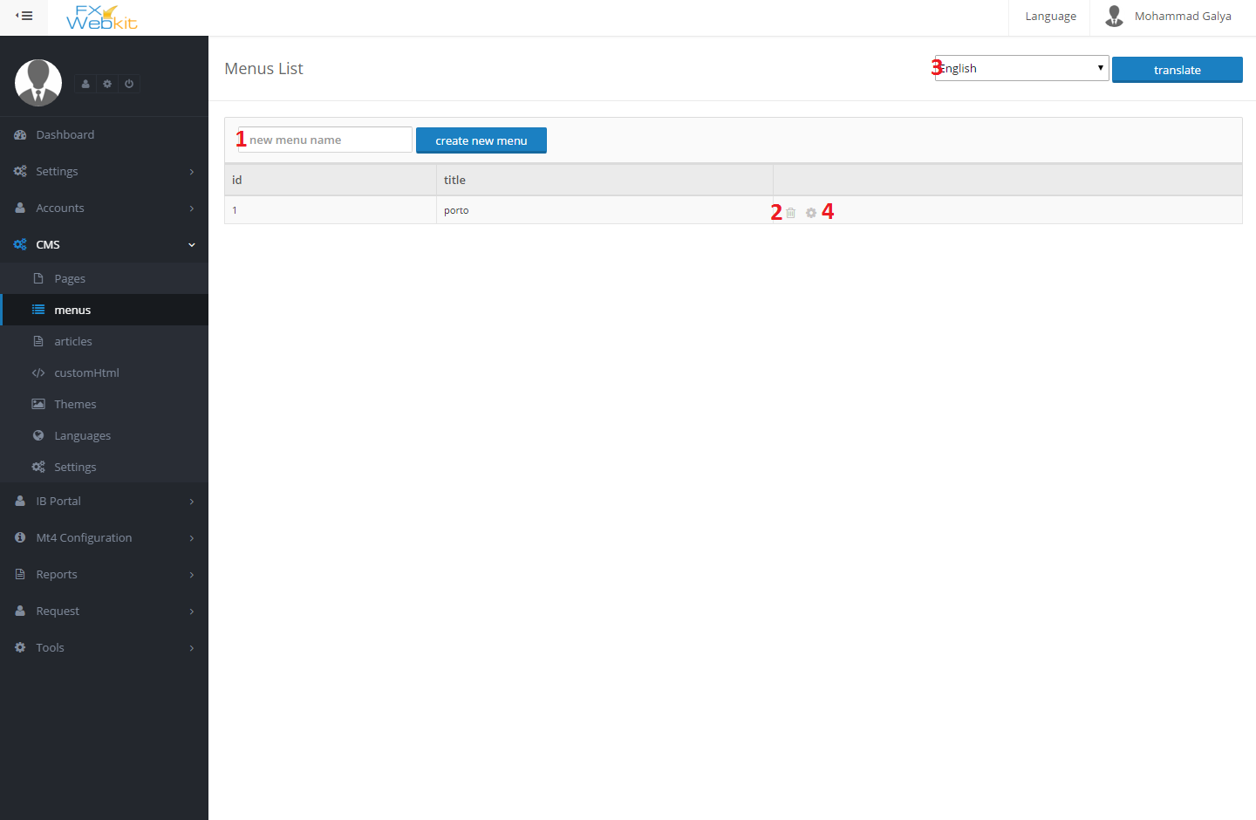

(figure 2.8)

1. **New menu name** : this name just to group menu items under one menu .
2. **Delete the menu**: delete the menu with all its menu items.
3. **Translate menu**: change language to translate the menu to another language.
4. **Add Menu items**: to add or remove menu item click this icon to get into (figure 2.9):-

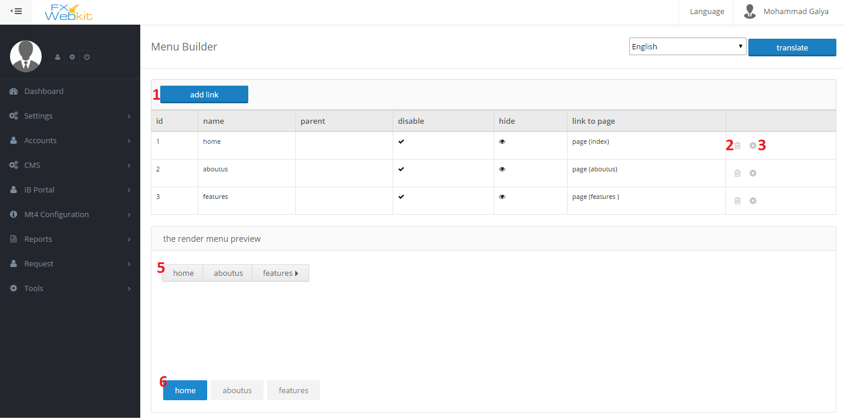

(figure 2.9)

1. **Add new link button**: click this button to insert link info (the next window describe the add menu item menu).
2. **Delete menu item** : remove the link from the menu and database.
3. **Edit menu item** : to change link refers to or configurations .
4. **Preview the menu** : this preview to show the standard rendering for this menu.
5. **Preview the menu with the current CMS theme**: how the menu will be look like in the public website.

**Add Menu Item window:-**

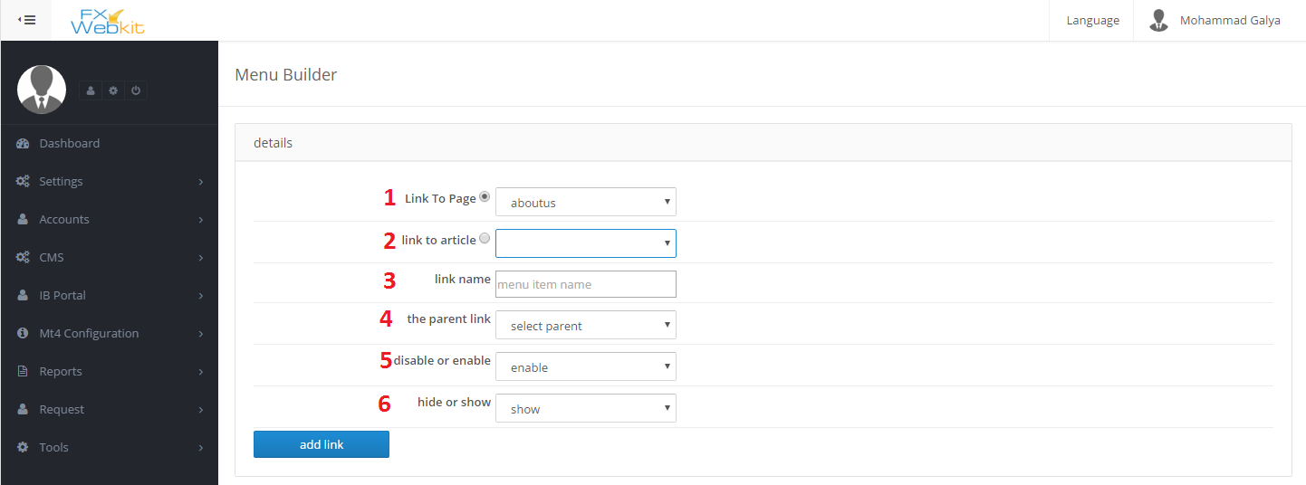

(figure 3.0)

1. **Link To Page**: menu item(the link) can go to the page or to article just check the radio button to the page and select the page name from the dropdown menu.
2. **Link To Article** : If you want to make this link refers to article check the **radio button** then select the article from the **drop down menu** then if the user in the public website he will go to the page which we select when we add new article in the CMS and the place(position) of the article in the page will be in the **MAIN ARTICLE PLACE** module which we drag and drop when we create the page.
3. **Link Name**: link name is the word which will displayed in the public website.
4. **The Parent Link**: to display this link under another link or sub of another link choose the parent link.
5. **Disable or Enable**: choose disable it will display but it will not be active on click on it
6. **Hide or show**: hide or show the link from public website.

**CMS Articles:-**

You can write any article and determine the page that this article display in so when you add new link to this article it will auto displayed in the selected page in the **MAIN ARTICLE PLACE.**

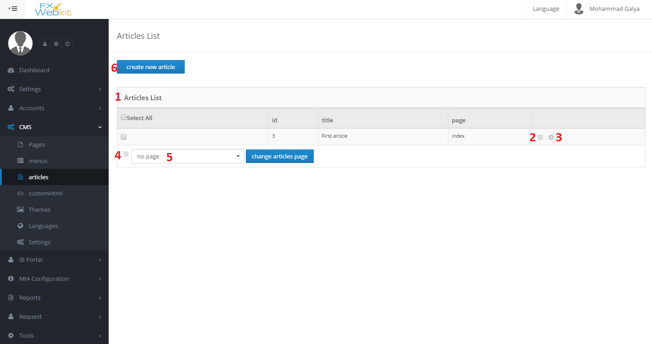

(figure 3.1)

1. **Article List**: all articles will be listed here.
2. **Remove the article** : remove the article with its translates.
3. **Edit the article** : to edit the article title and body , also you can insert new article using this article i.e. change this article and click insert new article in the edit article page so the original article will not be changed and new article with new edits will be created.
4. **Delete group of articles**: check the articles that you want to delete and click delete icon.
5. **Change article page**: as we see each article has a page, that page will be displayed when clicking on the article link in the public website link and the place of article will be **MAIN ARTICLE PLACE**, check the articles that you want to change its page (the display page) and choose the page click change articles page.
6. **Create New article**: to create new article (see figure 3.2) :-

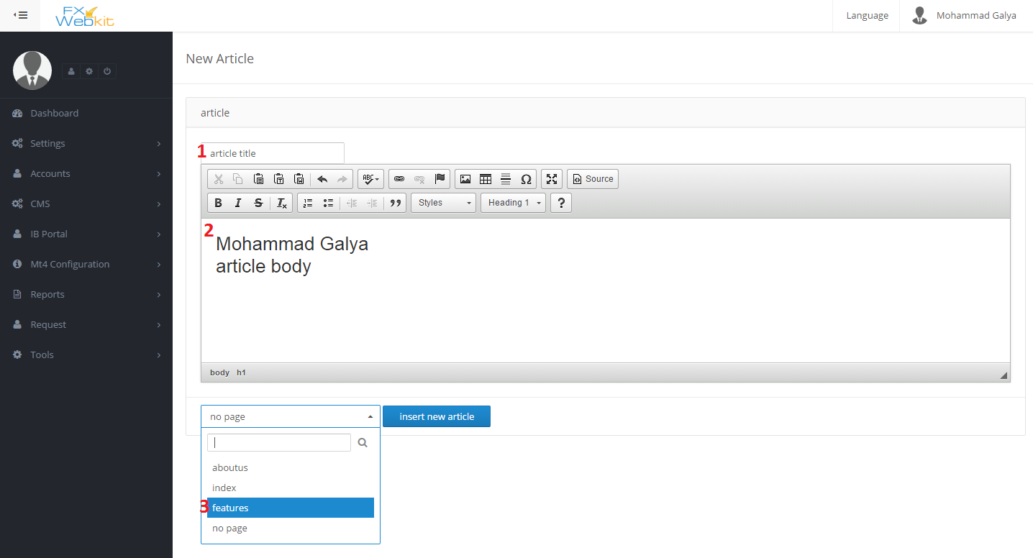

(figure 3.2)

1. **Article title**: this name will used for each use for this article and will not be displayed in the website.
2. **Article body**: the body of the article you can insert *html* and *CSS.*
3. **Article page** : the page which will display the article in its(page) **MAIN ARTICLE PLACE** position.

**Custom HTMl:**-  
same as article but no need to determine the page but you can insert it where ever you want in the page positions.

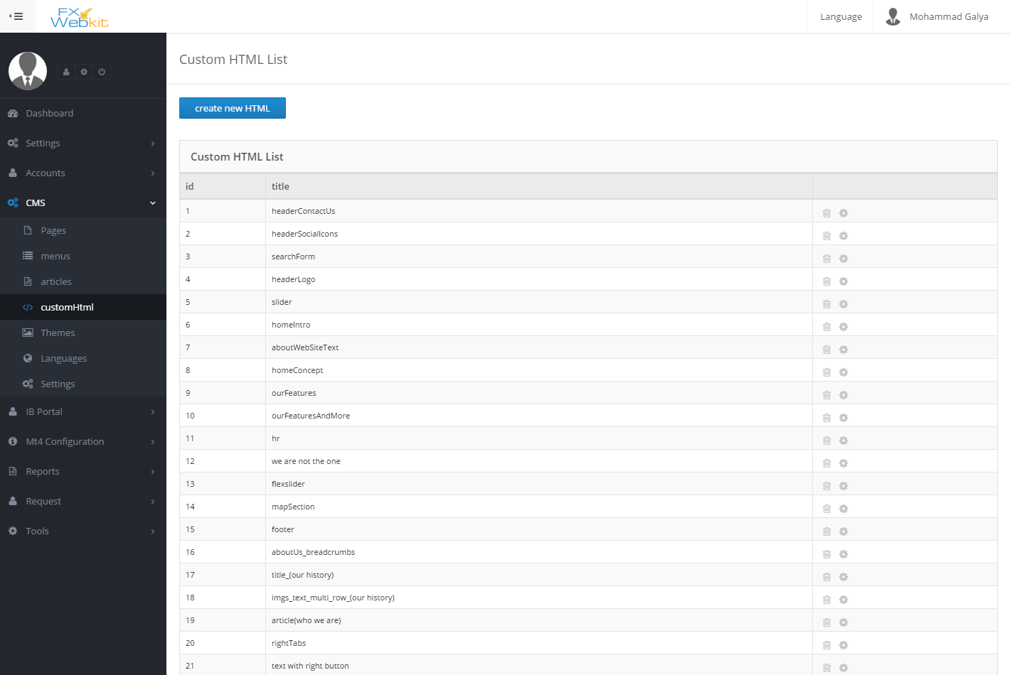

(figure 3.3)

**Languages:-**

To translate everything in CMS you need to insert the languages first then go to the wanted thing that you want translate ,select the language and translate.

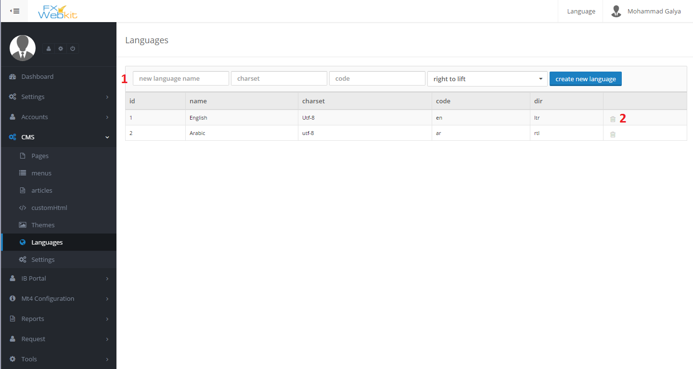

(figure 3.4)

1. **Language info**: insert language information name , charset, code and direction then create new language button.
2. **Delete language**: remove language and all translation for this language.

**CMS Settings:-**

These settings to configuration the CMS and theme developer settings :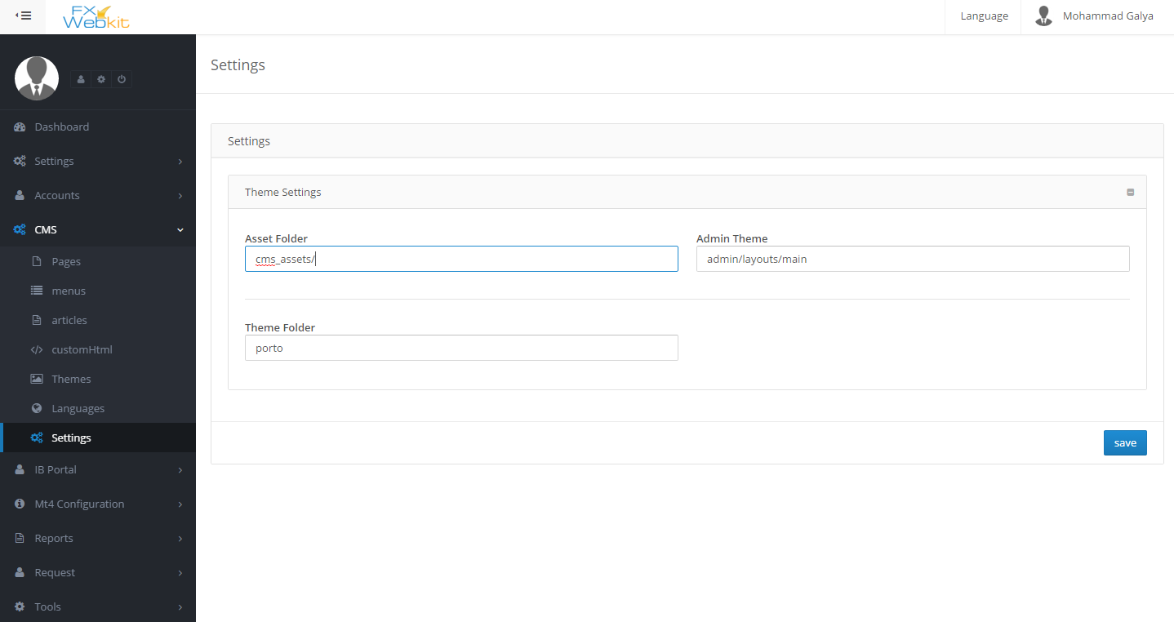

(figure 3.5)

**IP BORTAL**

To manage the agents and their configuration with plans for each agent.

**Feature:**

1. Easy to manage agents accounts.
2. Calculate agents commission and their users.

**IP BORTAL content:**

Plans:

The way of dealing with agent and how the commission will be calculate for each symbol :

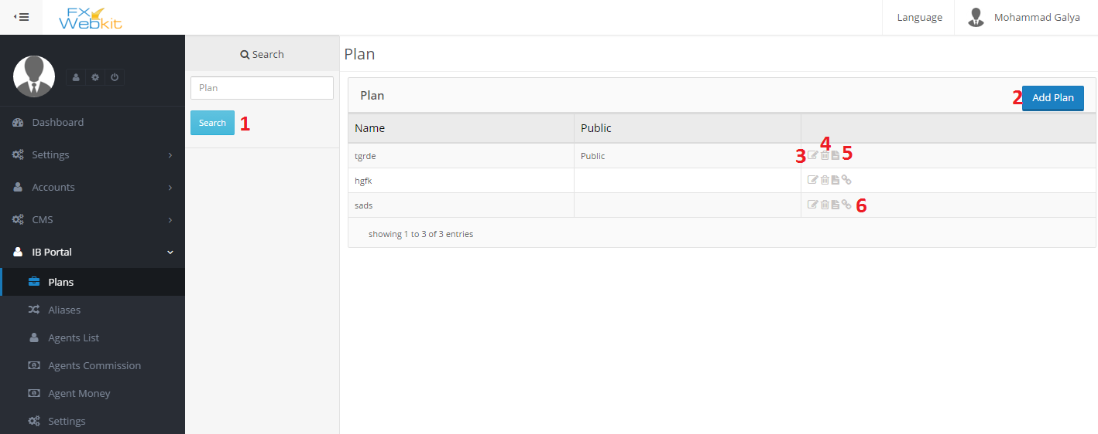

(figure 3.6)

1. **Search button**: To list plans click search button even if you do not search. The list will be empty until click search button .
2. **Add New Plan**: click add plan and insert plan name then type of the plan if its public it will be auto assign to new agent.
3. **Edit plan** : name and type(public and not public) can be edited here. also to add the symbols for this plan with (Rebate Type – Rebate Value) for each symbol.
4. **Delete plan** : remove plan icon.
5. **Plan details**: plan info with its symbols list with each symbol plan info.
6. **Assign users**: list of users(agents ) whose assigned to this plan and remove or add users to this plan.

**Aliases** :-

If We don't want to deal with symbols directly and deal with group of them depend on the name of symbols, like if we deal with all symbols starts with (contain –equals ) some litters :

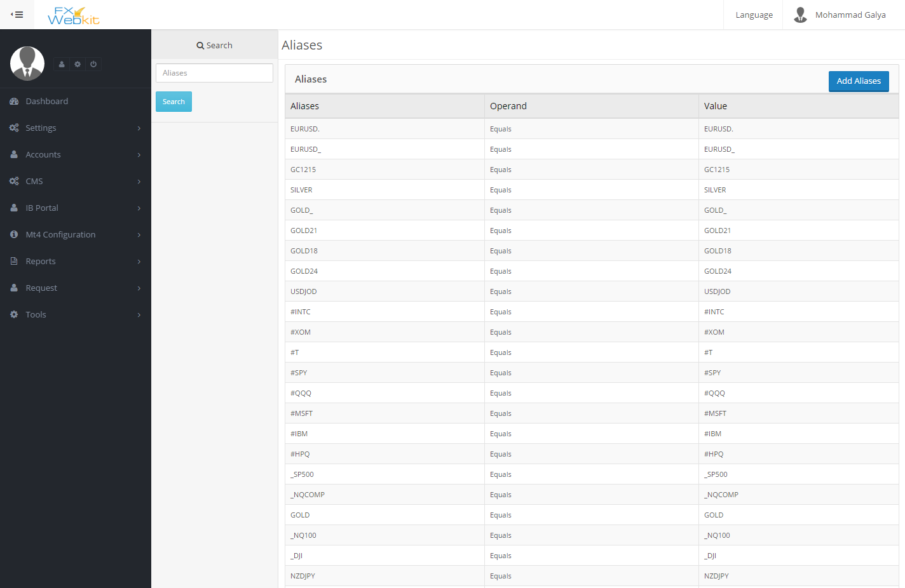

(figure 3.7)

List of aliases with search panel and add new aliases.

**Agents List**: -

Agents users are the users who agreed the agent agreement in **IBPORTAL** client area .

There are some users register in the **FXWEBKIT** software through him because for each agent plan there is link ,if any user register through this link this new user will be on agent users list and so with each trade for user the system calculate agent commission according to plan that the user register with its link.

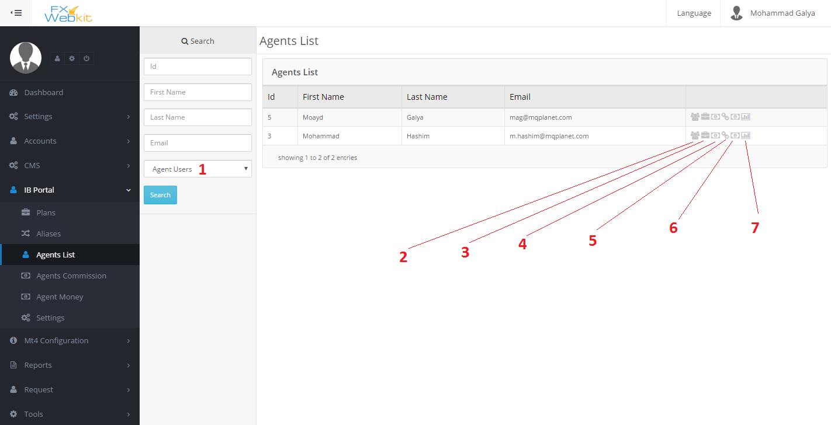

(figure 3.8)

1. **Filter users** : if you want to see all users and make one of them agent without his agree on agreement just select non-agent users and search then click on plus sign for the user.
2. **Agent users**: all users for this agent who register through him will be listed here .
3. **Agent Plans**: all the plans for this agent will be listed.
4. **Agent Commission** : agent commission for his users trades.
5. **MT user To give money for agent**: in this page you can determine MT4 user to transfer the agent money to.
6. **Agent money**: the list of money for the agent.
7. **Agent Summary** :some statistics and info for agent.

**Agents’ Commissions:-**

List of all agents’ commissions with filtrations:-

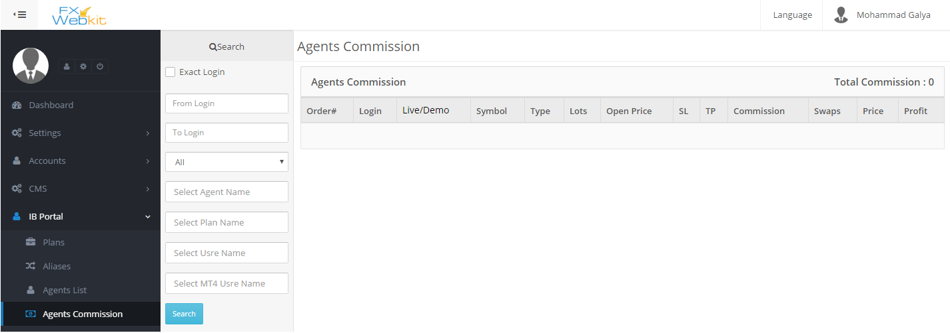

(figure 3.9)

**Agents’ Money:-**

List of all agents’ money with filtrations:-

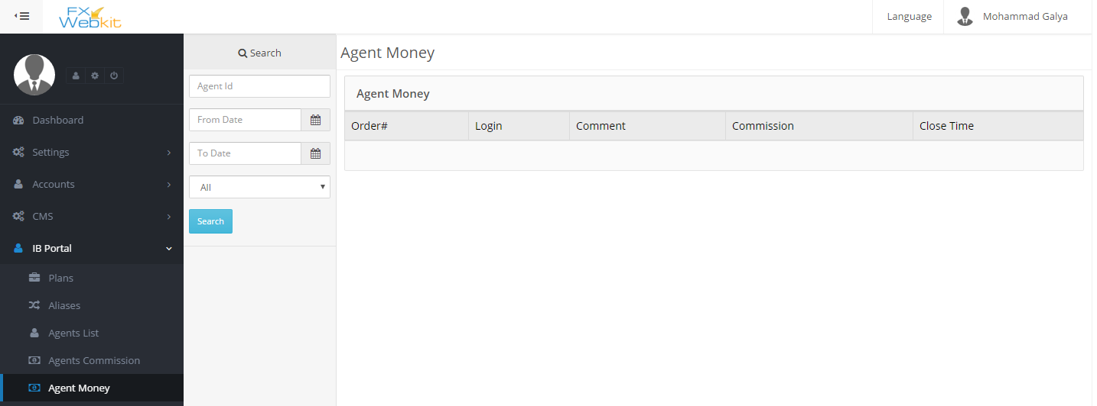

(figure 4.0)

**IBPORTAL settings:-**

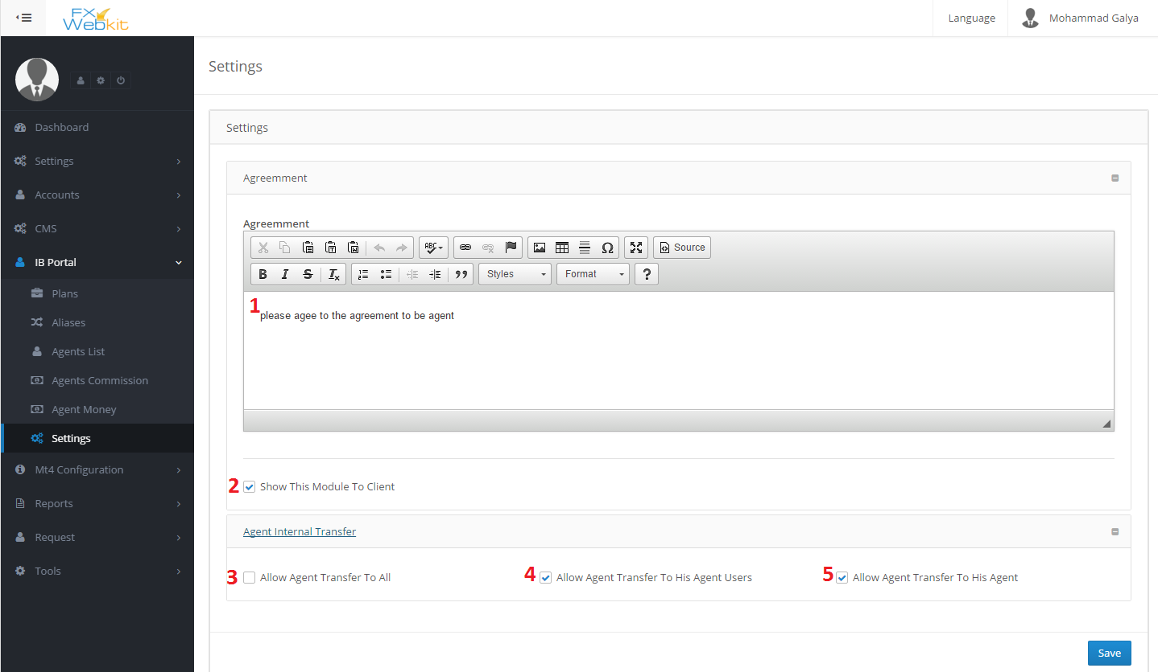

(figure 4.1)

1. **Agent agreement** : this agreement will be display for agent when he agree on it then he will be an agent.
2. **Show This Module to client**: to hide this module from client area or to show it.
3. **Allow Agent transfer to all**: This allow agent transfer money to all MT4 users.
4. **Allow agent transfer To his agent users**: this allow agent transfer money to MT users of agent users.
5. **Allow agent transfer to his agent** : this allow agent transfer money just to his MT users.

**MT4 Configurations :-**

The symbols , groups and securities lists come from MT server this module to get this lists from server and some API configurations.

**Symbols List:**

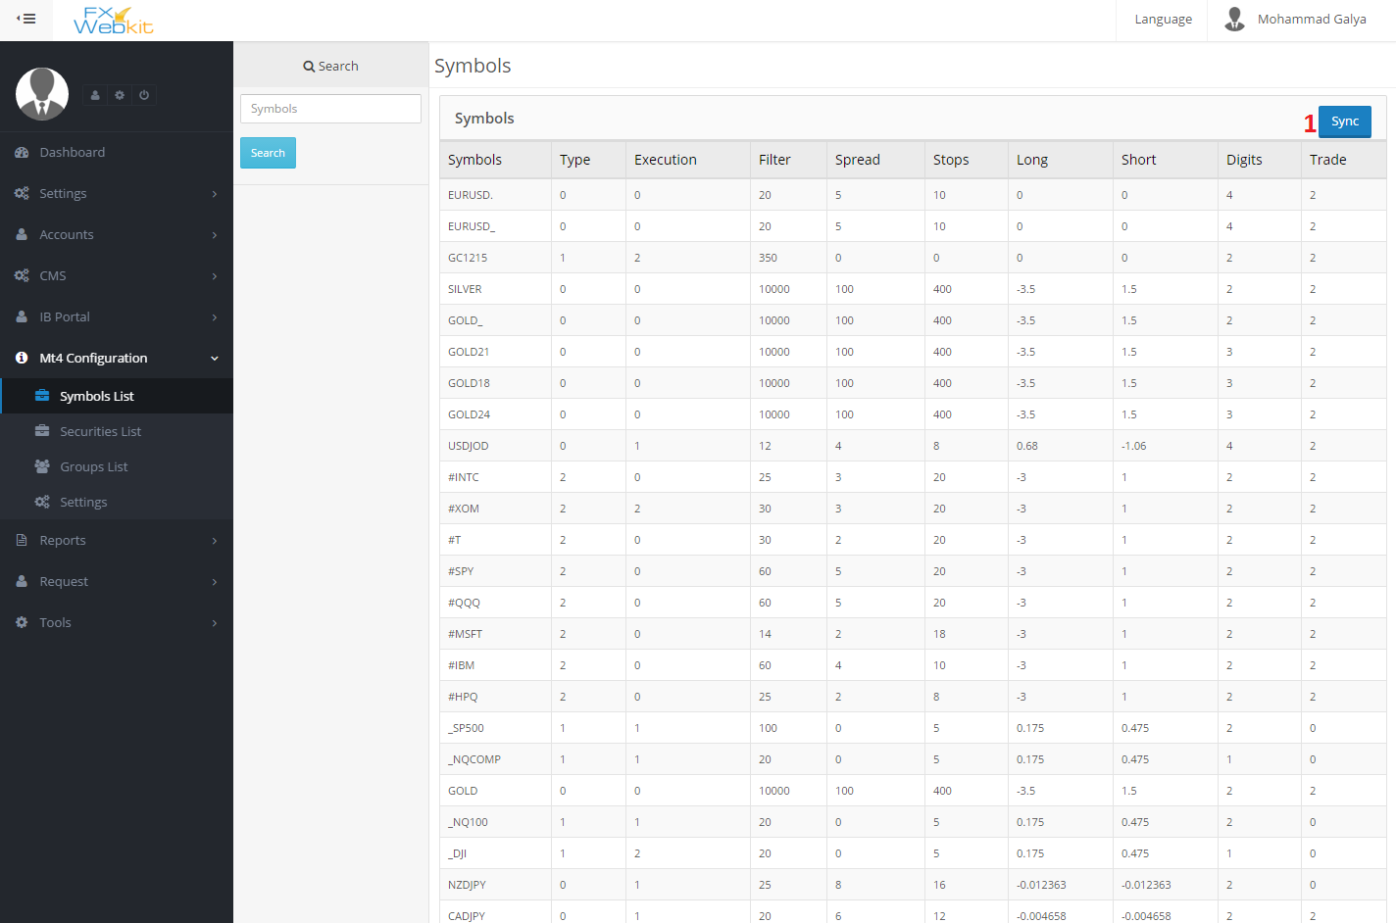

(figure 4.2)

1. **Synchronize** : synchronize symbols with symbols on MT server.

**Securities List:-**

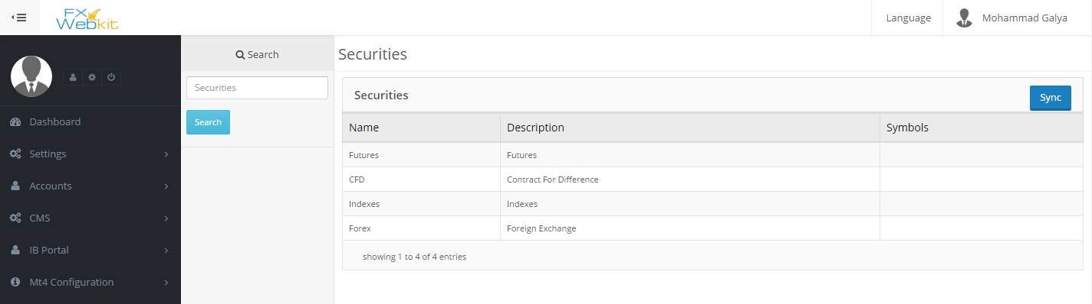

(figure 4.3)

**Groups List:-**

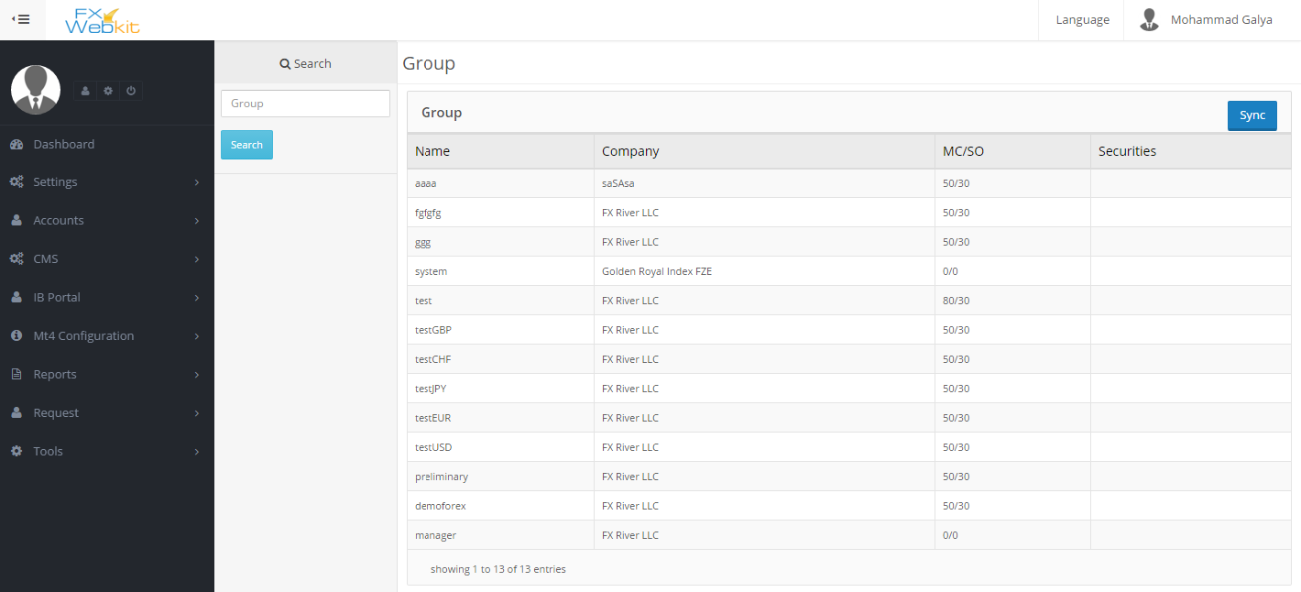

(figure 4.4)

**Settings:-**

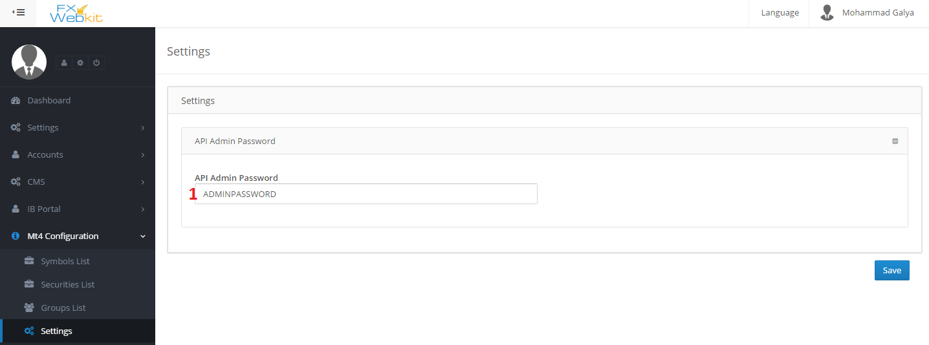

(figure 4.5)

1. **API Admin Password** :This password is to be sent with request for MT server , ask server API for it.

**Reports :-**

Reports about all trades and its users

**Closed Orders:-**

All trades closed orders for all users with filtrations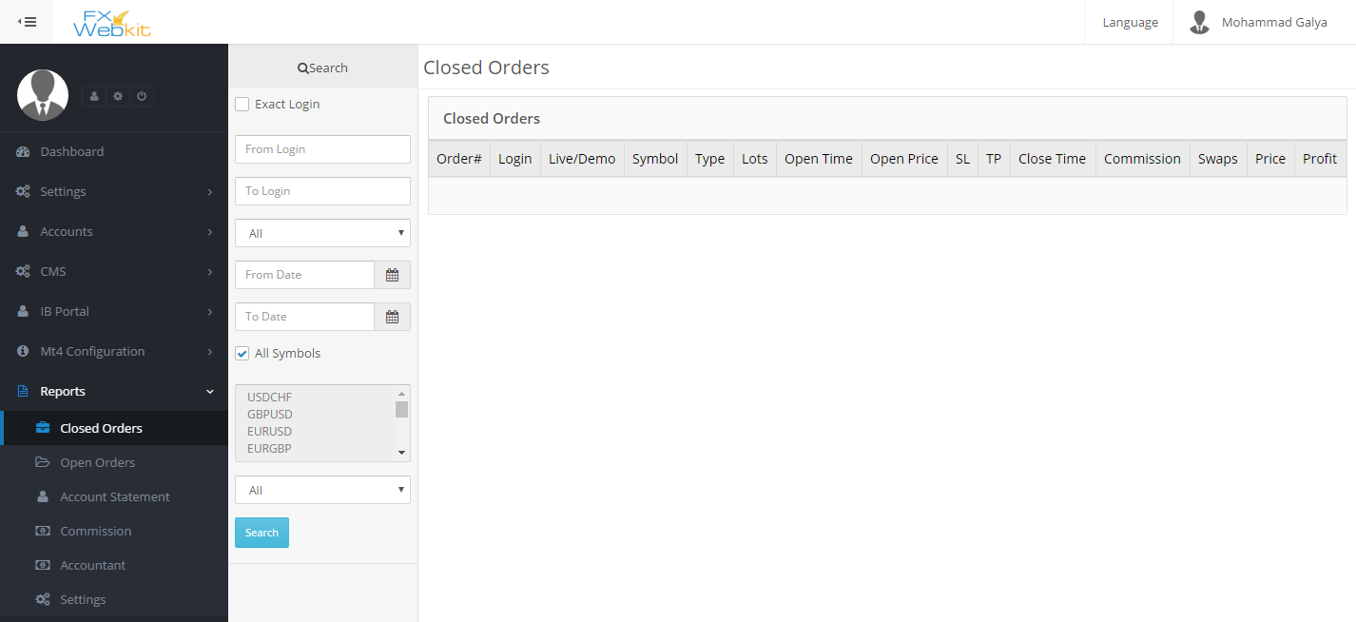

(figure4.6)

**Open Trades:-**

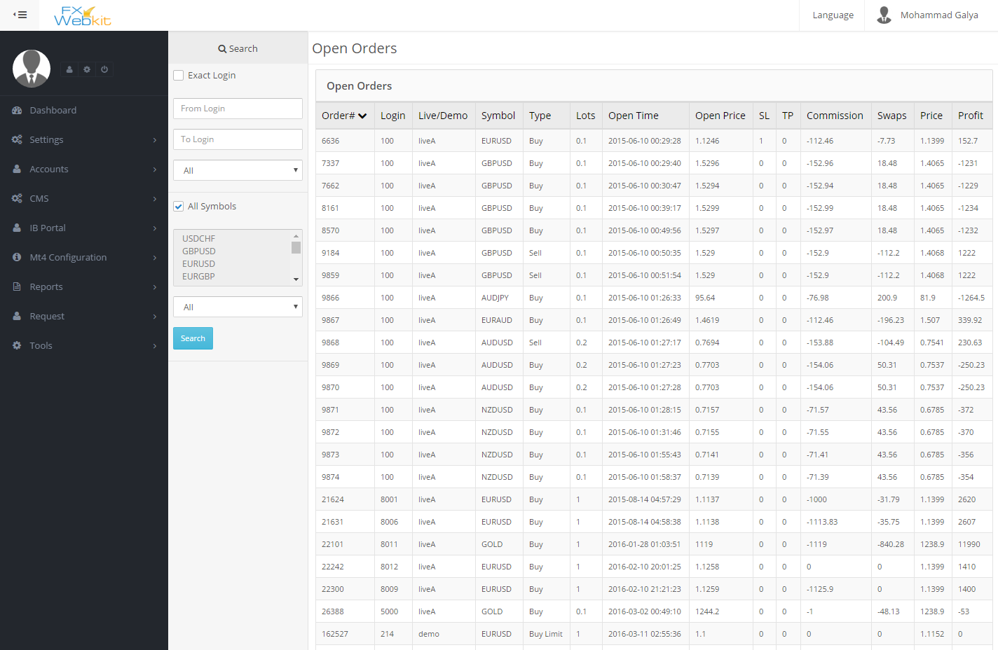

(figure 4.7)

**Account Statement :-**

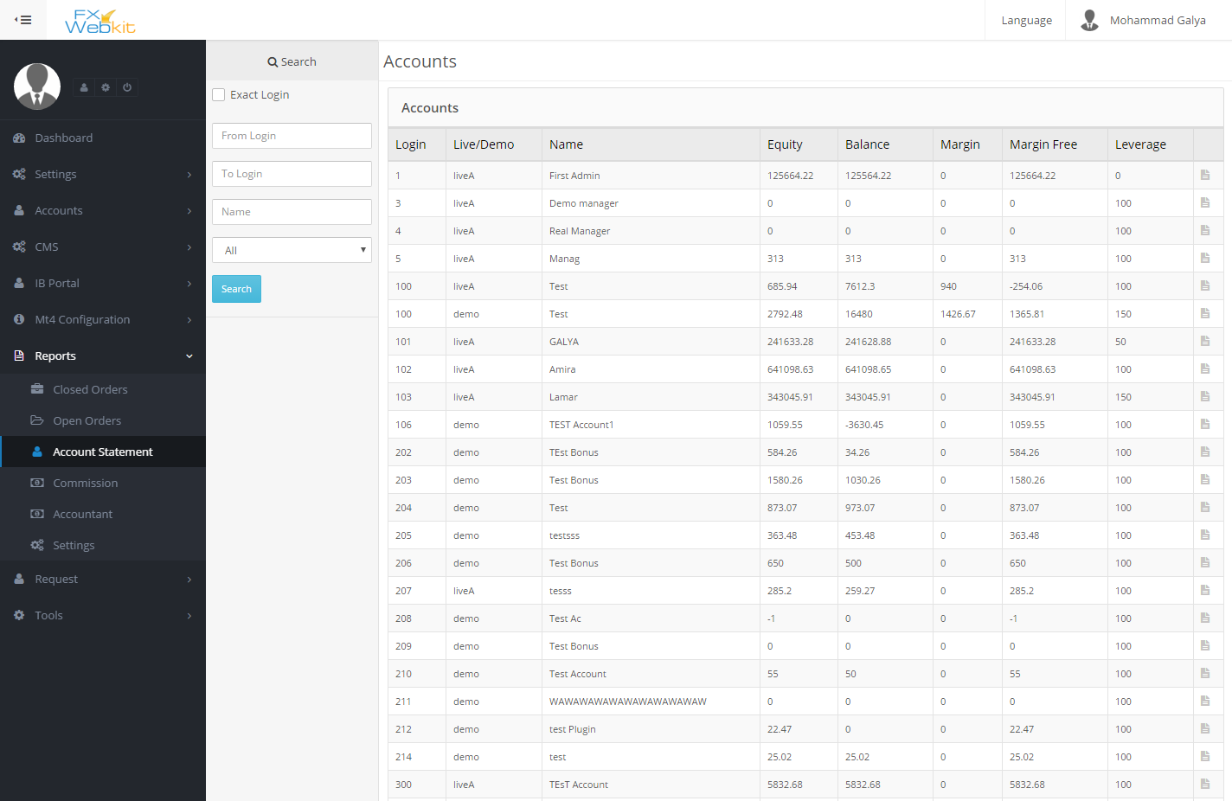

(figure 4.8)

**Commission :-**

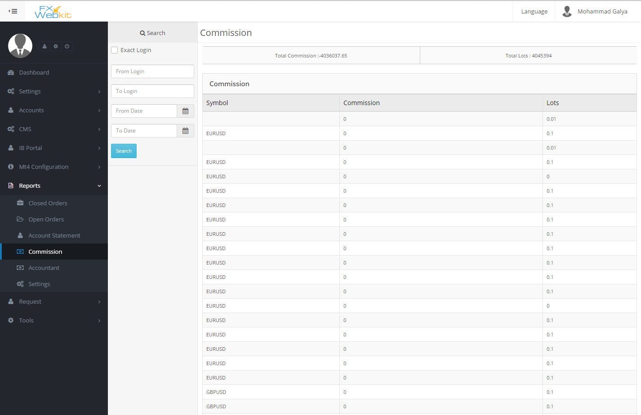

(figure 4.9)

**Accountant :-**

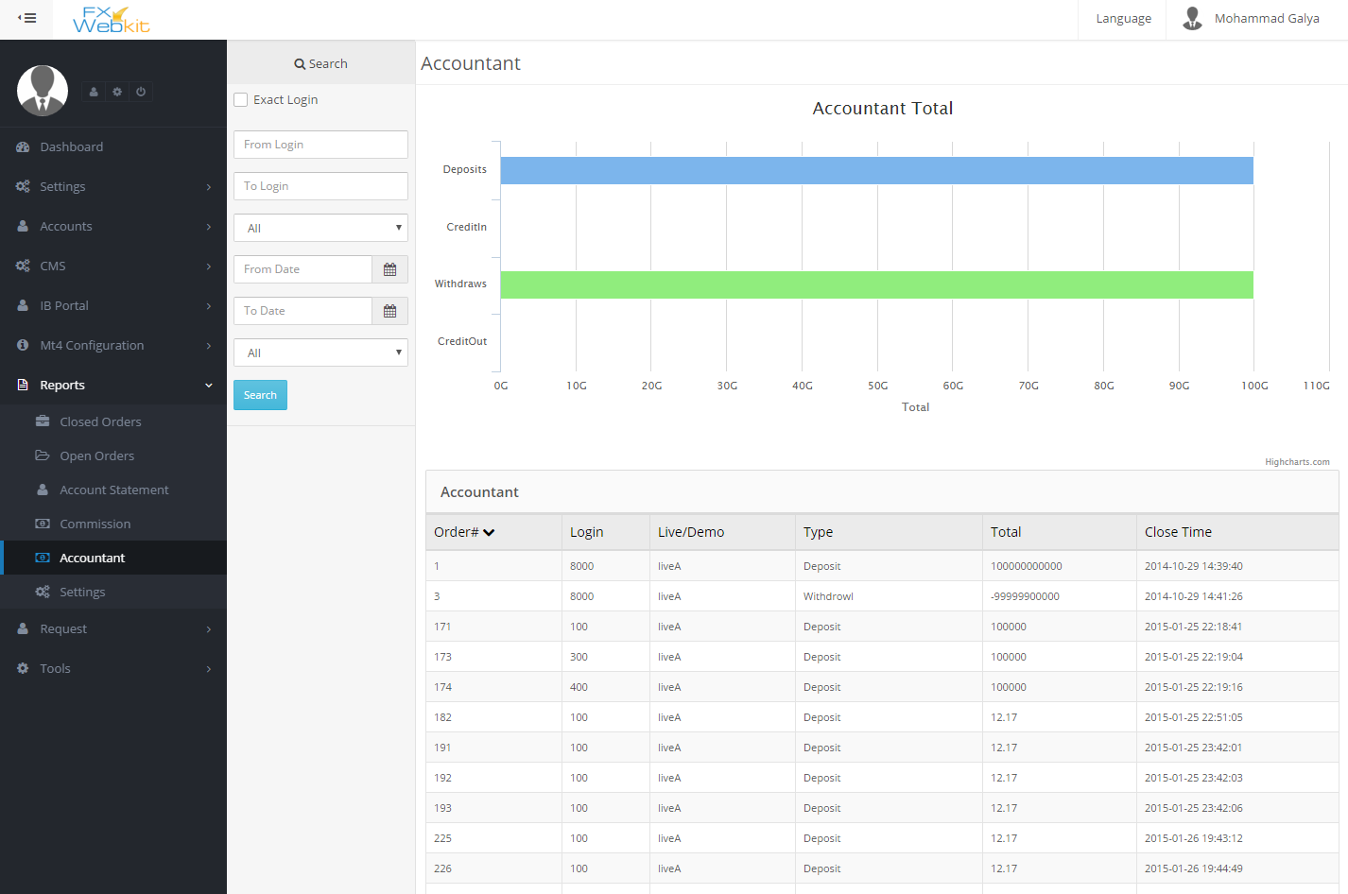

(figure 5.0)

**Settings:-**

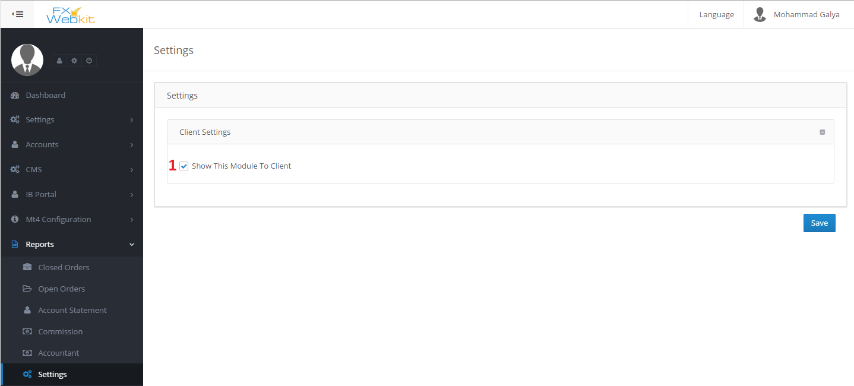

(figure 5.1)

1. **Show this module to client** : show and hide this module from client area .

**Requests: -**

This module purpose is to filter the client requests to the server and control them.

All users requests for MT4 server will be inserted in this module if the admin did not check **DIRECT ORDER TO MT4 SERVER**

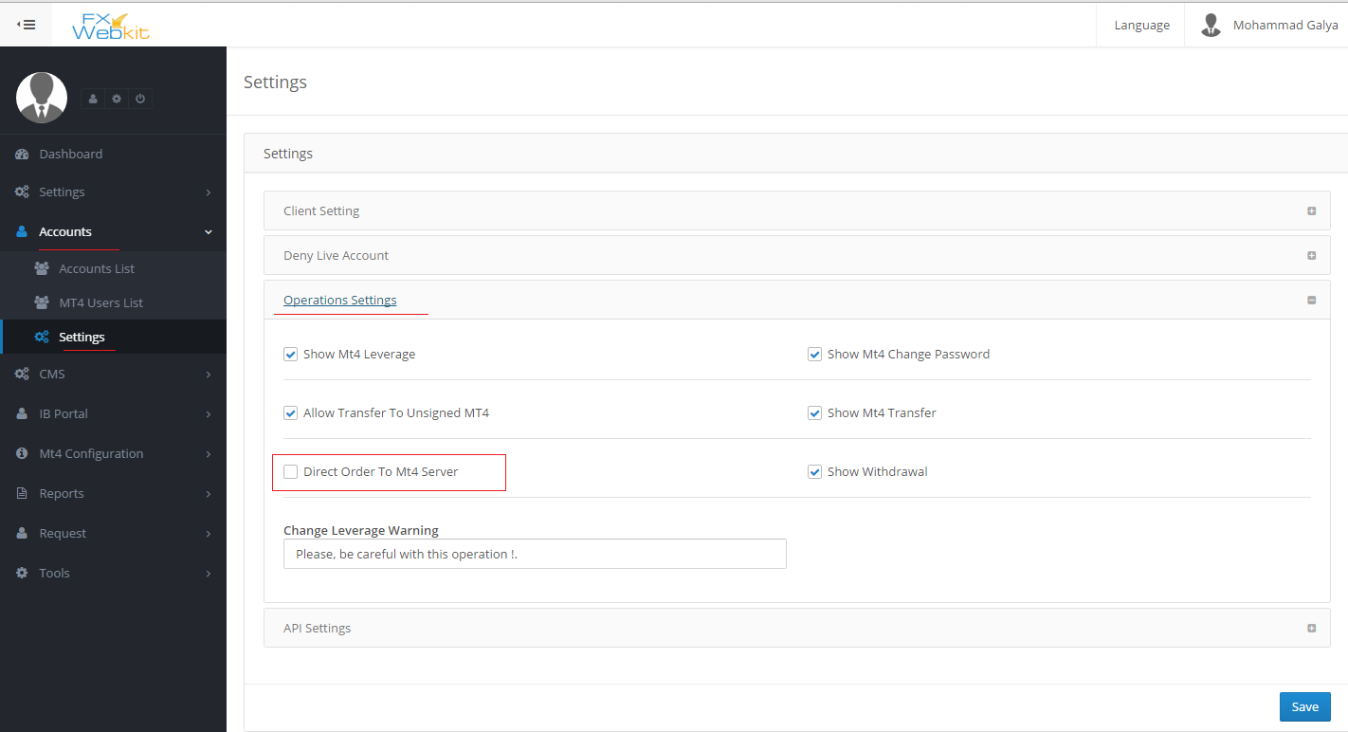

(figure 5.2)

**Features:-**

1. Full control to the MT server requests.
2. Complete the requests manual or forward it to the server.

**Sections**

**Internal Transfer :-**

All Internal transfer requests (if admin does not check direct request to the server) will listed here with request status .

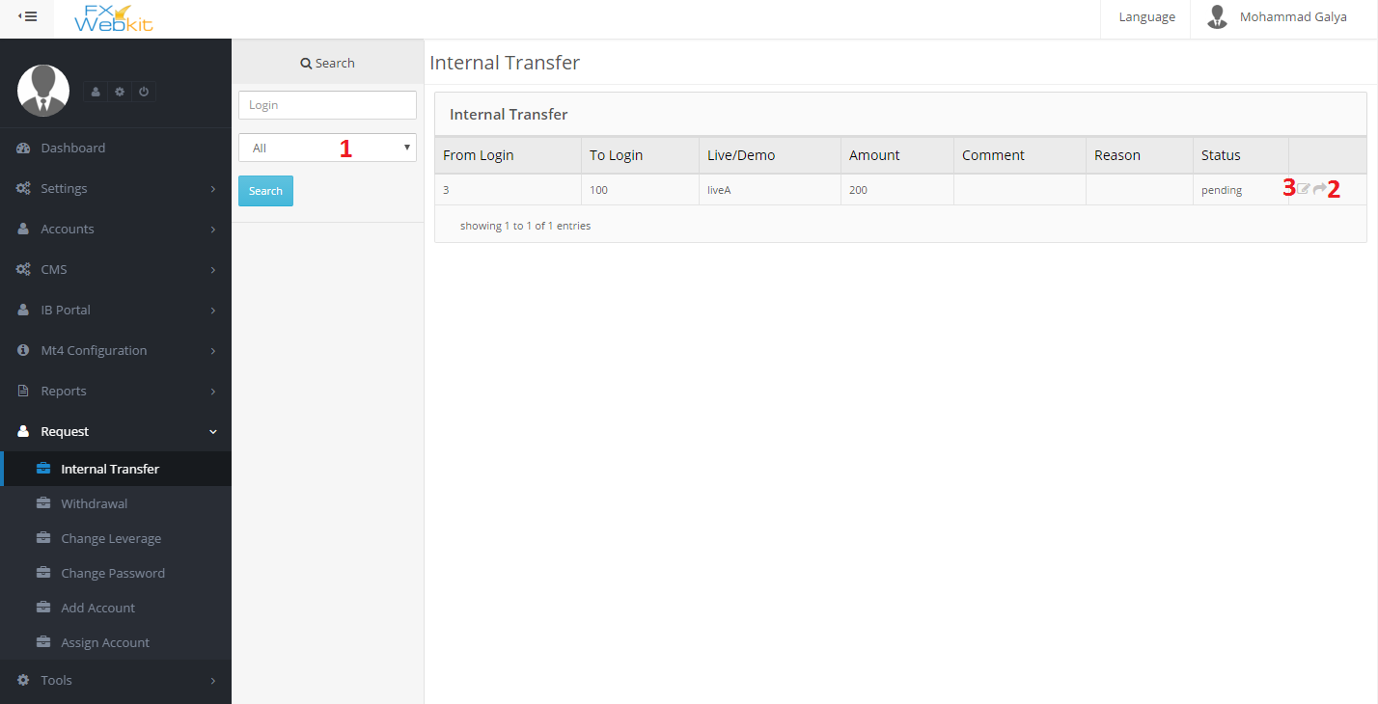

(figure 5.3)

1. **Filter requests** : to list the requests according to status (all - fail – pending – complete) , just select the status and click search.
2. **Forward request**: to forward the request to the server if the status is pending.
3. **Edit request** : you can edit the request status, comment and reason .

- Same thing for :

*Withdrawal requests, Change leverage requests, Change Password requests, and Add Account request.*

- But the Assign Account request when you change the status manual to complete the MT4 user will be assigned to the client(FXWEBKIT user).

**Tools Module:-**

This module contain some tools to help manage the trades .

**Features:-**

1. Manage contracts and expiry contract.
2. Check the holidays and trades hours and market watch.

**Contents:-**

**Future contracts:-**

When the contract expired there will be an email to the admin to users to till them there is expiry contracts

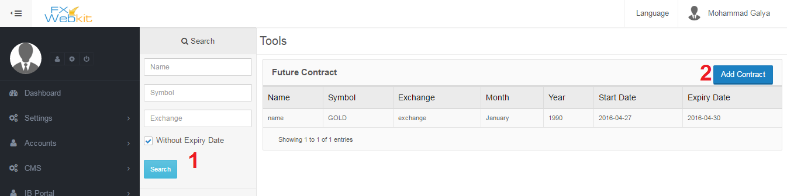

(figure 5.4)

1. **Filtration panel** : filter the contracts and click search button.
2. **Add New contract** : to insert new contract. (see figure 5.5)

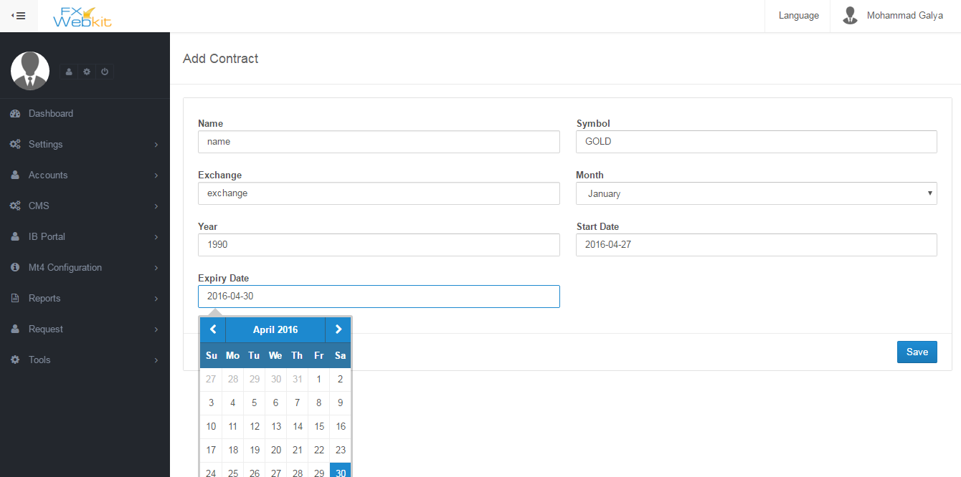

(figure 5.5)

**Market Watch :-**

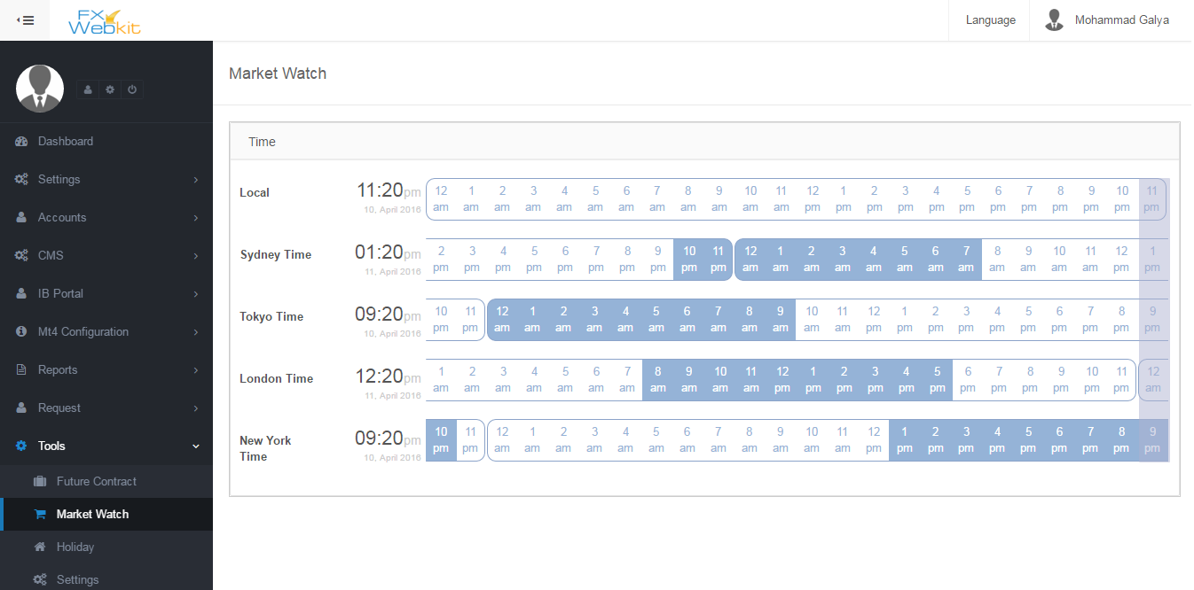

(figure 5.6)

-The blue color on time line represents open market.

**Holidays :-**

- In holidays we have to determine the open trade hours for each symbol:-

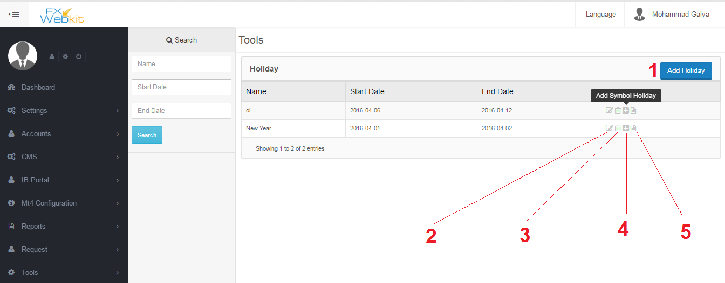

(figure 5.7)

1-**add Holiday** : this link allow you to insert basic holiday information ( holiday name –from date – to date) and to determine the trade hours for each symbol through this holiday (see number 4) .

2**- Edit holiday basic info** : just to edit basic holiday information ( holiday name – from date – to date).

1. **Delete holiday** : remove the holiday and all information.
2. **Add symbol holiday** : determine the trades hours for each symbol through this holiday, select the symbols group in some date and from hour to hour and click add then add another group of symbols with different time trades hour .
3. **Holiday details** : allow you to see the holiday details .

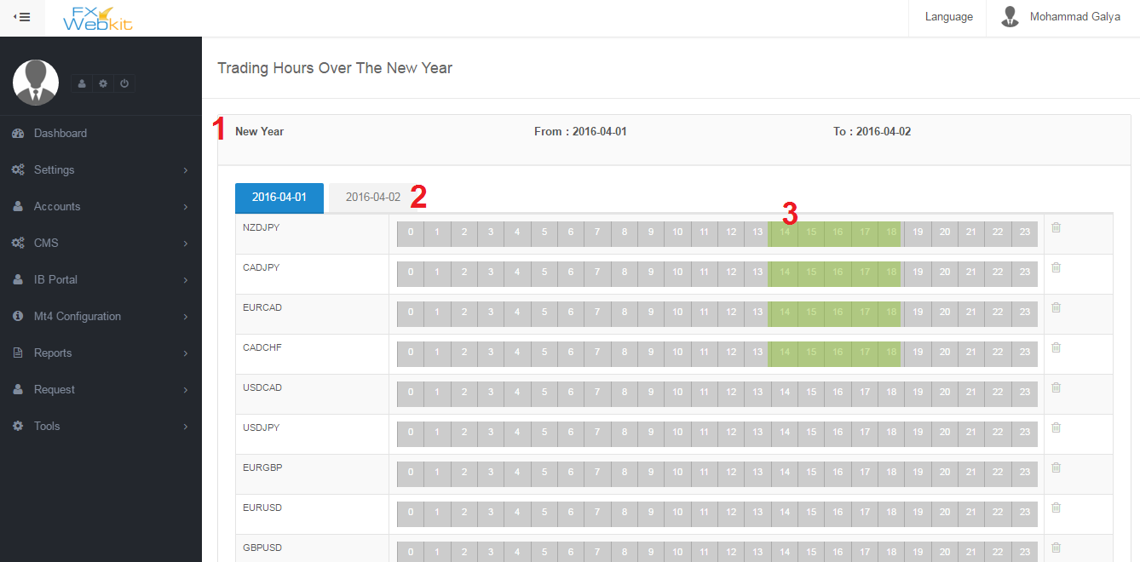

(figure 5.8)

1 **– holiday details** : basic holiday details.

2 – **dates of symbols trade hours** :when you add symbols for the holiday you select the date for trade hours for symbols and for each new date there will be new tab.

3 **– Trade hours** : the green color represent the open market for this symbol which listed on the left side bar .

**Settings :-**

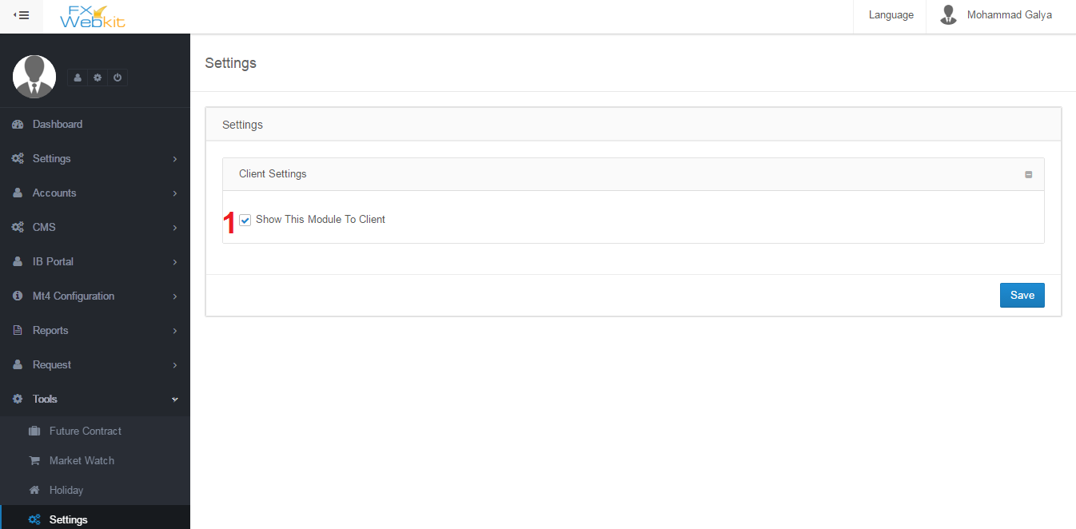

(figure 5.9)

1 – hide and display module in the client area .

**Client area**

-This area specialize for clients users to control their trades and MT users and their agent area.

***Features :-***

1. Control MT users and their trades .
2. Manage and analyses commissions and money for user.
3. Apply MT requests directly .
4. Use FXWEBKIT tools.

***-Sections :-***

*Dashboard:-*

-Client dashboard contain analyses for MT users trades and some statistics for MT users and their trades .

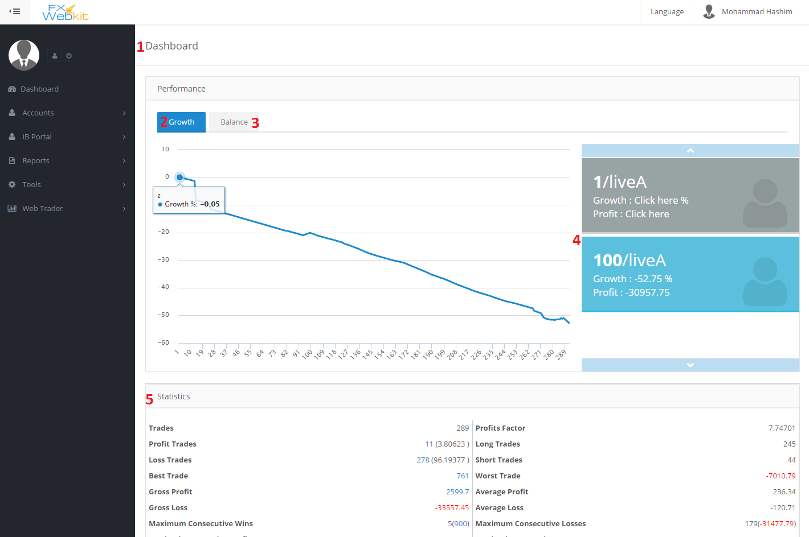

(figure 6.0)

1. **Client Dashboard** : the main page for client to help him analyze his trades with his MT users.
2. **Growth Chart** : to see each MT user growth chart just click on the MT user at the left side.
3. **Balance Chart** : this tab to see balance chart for the selected MT user
4. **MT user list** : all MT users whose assigned to this client .
5. **Statistics** : those are statistics for the selected MT user’s trades.

***Accounts*:-**

-This module to manage MT users for this client and apply some activities on them with requests to the MT server.

**Add MT user :**

For each client on FXWEBKIT software there are number of MT users those MT users can be added through client himself by this page if the admin allow direct order for MT server the request will be auto go to the server otherwise the request will go to the admin and the admin decide .

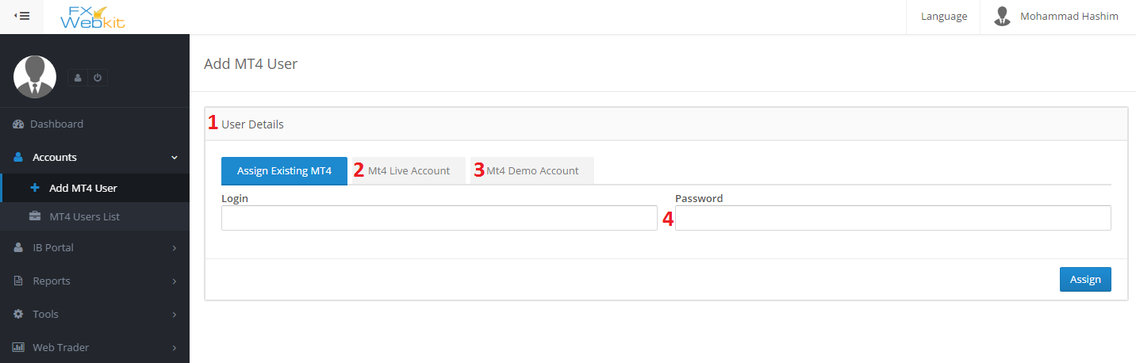

(figure 6.1)

1. **MT user details** : type the login and the password for an existing MT user in MT server and assign him to this client .
2. **Create New MT Live user** : if the client want to create new MT user which is not existed on the MT server, he has to go to this tab insert new MT user and click add ,if the admin allow direct order for MT server the request will be auto ,go to the server and the result ( if success ) the new MT user will be assigned to this client.
3. **Create Demo MT user** : same thing with a live user but this request will go to the demo MT server.
4. **MT user Password**: this will be optional if the admin request it from admin public settings .

**MT Users List :-**

-All the MT users who are assigned to the client from the admin or by added MT user tab, will be listed here so the client can see them and apply some MT server requests

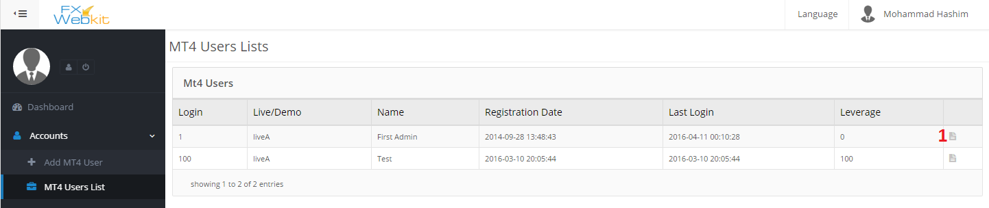

(figure 6.2)

**MT user details:-**

details for the MT user and apply some action on this MT user like change password , change leverage and transfer but all those actions can be hidden from admin side.

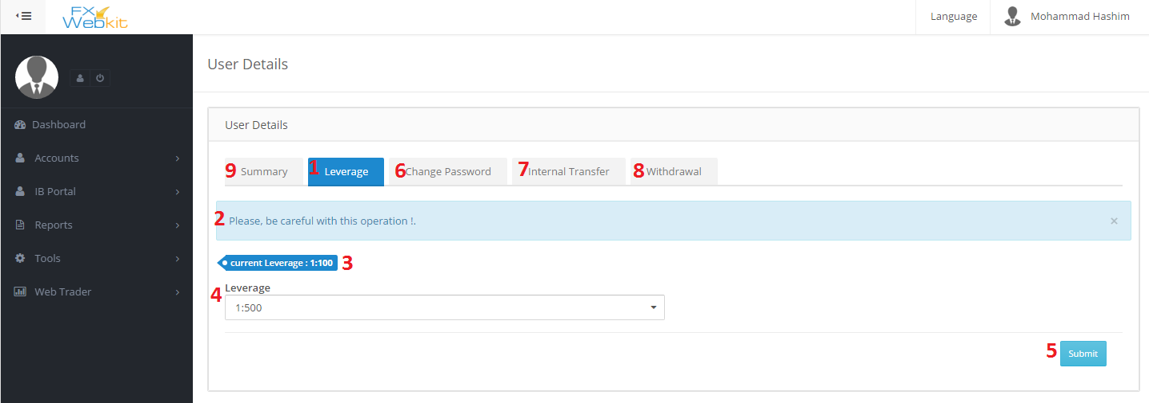

(figure 6.3)

1. **Leverage** : to change the current leverage for selected MT user.
2. **Warning Message** :this message from admin settings to warn user if he want to change the leverage.
3. **Current leverage** : leverage for selected MT user.
4. **Select leverage** : list of all leverages will be listed except the current leverage.
5. **Submit** : apply new changes but if the admin does not choose to direct request to the MT server option the request will be sent to the admin first so the admin can decide.
6. **Change MT user password** : to change current password to new password for selected MT user.
7. **Internal Transfer** : transfer money from this MT user to another one depend on admin settings the client can transfer money from this MT user to any MT user or just for his (client) MT users.
8. **Withdrawal** : withdrawal from this MT user account.
9. **Summary** : MT details and information's.

**IB Portal :-**

We have talk about this module in the admin area here is the same thing but for one client and his users.

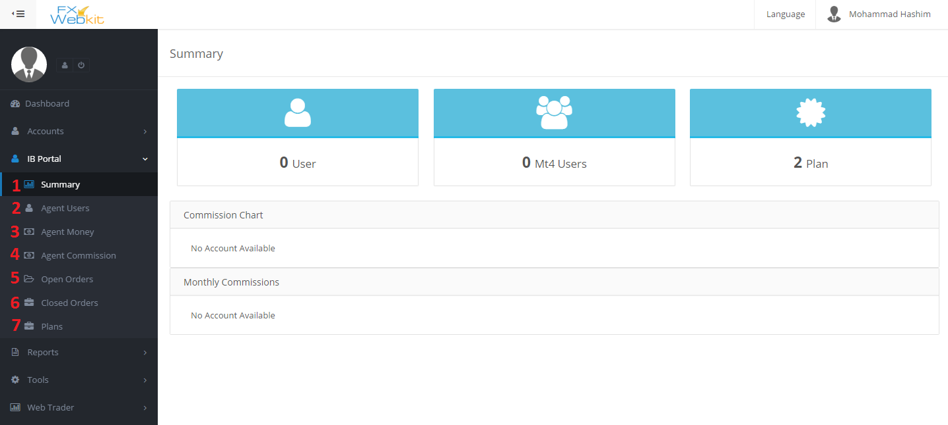

(figure 6.4)

1. **Summary** : some info about the agent and his users with commission .
2. **Agent Users** : the users who are registered in the FXWEBKIT system through this Client .
3. **Agent Money** : the money of the client which he gets that depend on his agent’s users .
4. **Agent commission** : the commission from the trades of agent’s users MT users.
5. **Open Orders** : all agent’s users MT users open trades orders listed here with filtration.
6. **Closed Orders** : all agent’s users MT users closed trades orders listed here with filtration.
7. **Plans** : list of plans that the admin assigned to this client.

**Reports:-**

-We have talk about this module in the admin area here is the same thing but for one client and his users.

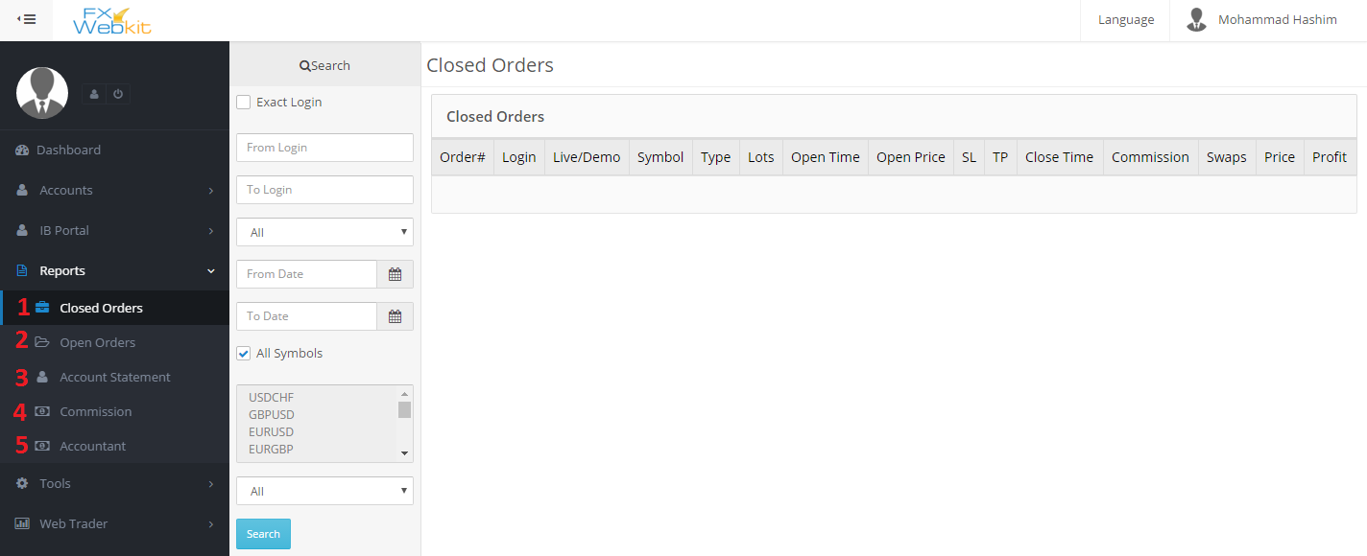

(figure 6.5)

1. **Closed Orders** : list of Closed trade orders of MT users of this client.
2. **OpenOrders** : list of open trade orders of MT users of this client.
3. **Account statement** of MT users of this client.
4. **Commissions** : commission of client’s MT users .
5. **Accountant** : accountant of client’s MT users .

**Tools:-**

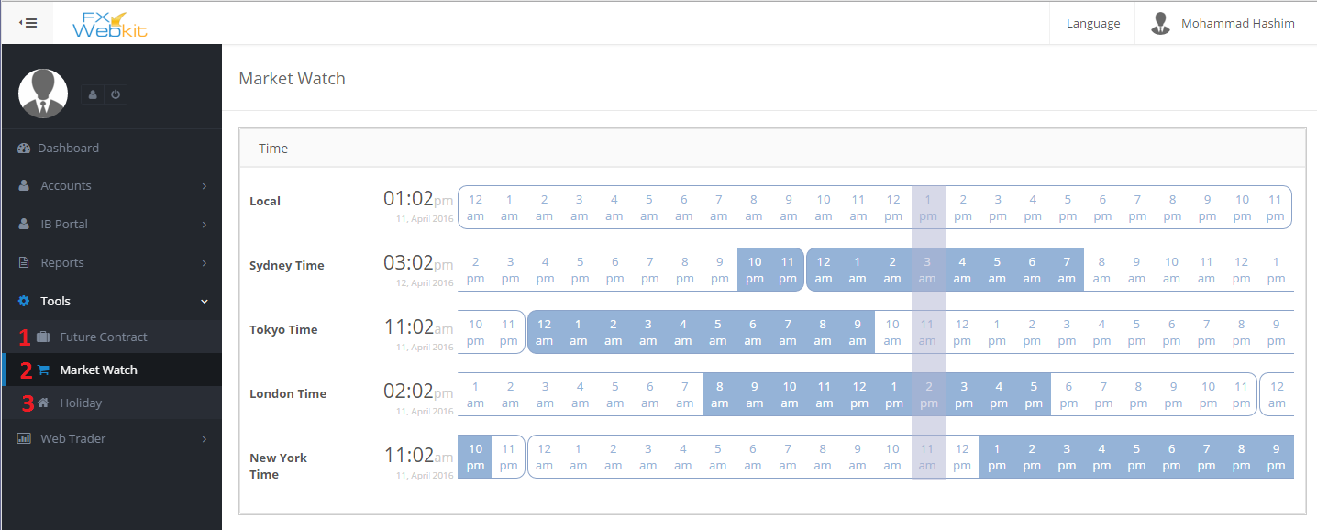

(figure 6.6)

1. **Future Contract**: list of future contract and filtrations for the list.
2. **Market Watch** : trades Markets open hours .
3. **Holiday** : list of holidays and their details.

**Web trader:-**

-Web trader allow you to trade through the web site just insert MT user info and feel free to trade as you want

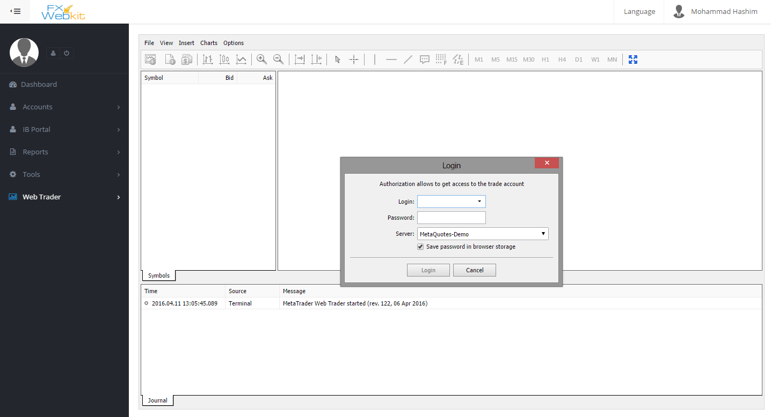

(figure 6.7)

-This link(web trader) can be hidden from admin settings